UNITED STATES
SECURITIES AND EXCHANGE COMMISSION
Washington, D.C. 20549

FORM 8-K

CURRENT REPORT
Pursuant to Section 13 or 15(d) of the Securities Exchange Act of 1934

Date of Report (date of earliest event reported): September 3, 2026
GENESCO INC.
(Exact name of registrant as specified in its charter)

Tennessee | 1-3083 |  | 62-0211340
(State or Other Jurisdiction  of Incorporation) | (Commission  File Number) |  | (I.R.S. Employer  Identification No.)
535 Marriott Drive | Nashville | Tennessee | 37214
(Address of Principal Executive Offices) |  |  | (Zip Code)

(615) 367-7000
Registrant's telephone number, including area code

Not Applicable
(Former Name or Former Address, if Changed Since Last Report)

Check the appropriate box below if the Form 8-K filing is intended to simultaneously satisfy the filing obligation of the registrant under any of the following provisions (see General Instruction A.2. below):

☐ |  | Written communications pursuant to Rule 425 under the Securities Act (17 CFR 230.425)

☐ |  | Soliciting material pursuant to Rule 14a-12 under the Exchange Act (17 CFR 240.14a-12)

☐ |  | Pre-commencement communications pursuant to Rule 14d-2(b) under the Exchange Act (17 CFR 240.14d-2(b))

☐ |  | Pre-commencement communications pursuant to Rule 13e-4(c) under the Exchange Act (17 CFR 240.13e-4(c))

Securities registered pursuant to Section 12(b) of the Act:

Title of each class | Trading Symbol(s) | Name of exchange on which registered
Common Stock, $1.00 par value | GCO | New York Stock Exchange

Indicate by check mark whether the registrant is an emerging growth company as defined in Rule 405 of the Securities Act of 1933 (§230.405 of this chapter) or Rule 12b-2 of the Securities Exchange Act of 1934 (§240.12b-2 of this chapter).
Emerging growth company ☐
If an emerging growth company, indicate by check mark if the registrant has elected not to use the extended transition period for complying with any new or revised financial accounting standards provided pursuant to Section 13(a) of the Exchange Act.
☐

ITEM 2.02. RESULTS OF OPERATIONS AND FINANCIAL CONDITION.
On September 3, 2026, Genesco Inc. issued a press release announcing results of operations for the second fiscal quarter ended August 1, 2026. A copy of the press release is furnished as Exhibit 99.1 to this Current Report on Form 8-K.
On September 3, 2026, the Company also posted on its website, www.genesco.com, a slide presentation with summary results. A copy of the slide presentation is furnished as Exhibit 99.2 to this Current Report on Form 8-K.
In addition to disclosing financial results calculated in accordance with United States generally accepted accounting principles (GAAP), the press release furnished herewith contains non-GAAP financial measures, including adjusted gross margin, selling and administrative expenses, operating income (loss), interest, net, pretax earnings (loss), earnings (loss) from continuing operations and earnings (loss) per share from continuing operations, as discussed in the text of the release and as detailed on the reconciliation schedule attached to the press release. For consistency and ease of comparison with the adjusted results for the prior period announced last year, the Company believes that disclosure of the non-GAAP measures will be useful to investors.
ITEM 9.01. FINANCIAL STATEMENTS AND EXHIBITS.
(d) Exhibits
The following exhibits are furnished herewith:

Exhibit Number |  | Description
99.1 |  | Press Release issued by Genesco Inc. on September 3, 2026
99.2 |  | Genesco Inc. Second Quarter ended August 1, 2026 Summary Results
104 |  | Cover Page Interactive Data File (embedded within the Inline XBRL document)

SIGNATURES
Pursuant to the requirements of the Securities Exchange Act of 1934, the Registrant has duly caused this report to be signed on its behalf by the undersigned hereunto duly authorized.

 |  | GENESCO INC.
Date: September 3, 2026 |  | By: |  | /s/ Jonathan M. Collins
 |  | Name: |  | Jonathan M. Collins
 |  | Title: |  | Senior Vice President - Finance and Chief Financial Officer

Exhibit 99.1

GENESCO INC. REPORTS FISCAL 2027 SECOND QUARTER RESULTS
--Operating Income and EPS Improvement Exceed Expectations and Last Year--
-- Journeys Comparable Sales +2%, Johnston & Murphy Comparable Sales +4%--
--Eighth Consecutive Quarter of Positive Total Comparable Sales Growth for Journeys--
--Raises EPS Guidance --

NASHVILLE, Tenn., Sept. 3, 2026 --- Genesco Inc. (NYSE: GCO) today reported second quarter results for the three months ended August 1, 2026.

Second Quarter Fiscal 2027 Financial Summary
GAAP results include tariff refunds as well as other one-time adjustments; adjusted (Non-GAAP) results exclude these items to better reflect underlying operating performance

•
Net sales of $530 million decreased 3% compared to Q2FY26
•
Comparable sales decreased 1% compared to last year, with stores up 1% while e-commerce decreased 6%
•
Gross margin improved 560 basis points compared to last year, reflecting tariff refunds; Adjusted gross margin improved 140 basis points compared to last year1
•
Operating margin improved 330 basis points compared to last year; Adjusted operating margin improved 100 basis points compared to last year1
•
GAAP EPS was $0.32 and Non-GAAP EPS was ($0.83)1 versus GAAP EPS of ($1.79) and Non-GAAP EPS of ($1.14) last year2
•
Raises adjusted EPS guidance to high end of $2.00 to $2.40 range versus midpoint last quarter

Mimi E. Vaughn, Genesco’s Board Chair, President and Chief Executive Officer, said, “We delivered second quarter bottom line results that were significantly better than last year and well ahead of our expectations. The quarter provides further evidence that our Footwear First strategy is working and our momentum is building. Journeys and Johnston & Murphy both delivered positive comparable sales in the quarter, and earnings improvement reflected the operating leverage we set out to build, with more full-price selling aiding gross margin recapture and disciplined expense management driving the stronger performance. As we anticipated, the decline in sales was driven by strategic actions: store closures, our license transition, and pullback on discounting at Schuh. As we move past these shorter-term headwinds, we expect sales trends to improve, and we remain confident that the initiatives underway across our company position us for profitable growth.”

__________________________
1Non-GAAP earnings per share (“EPS”), adjusted operating loss and adjusted gross margin are non-GAAP measures. Non-GAAP EPS results exclude tariff refund-related benefits and certain one-time costs, net of tax, including proxy contest and other legal expenses, information technology transformation costs, severance and other restructuring costs in the second quarter of Fiscal 2027 and severance, net of tax, in the second quarter of Fiscal 2026 (“the Excluded Items”). See Schedule B for reconciliations to GAAP measures. The Company believes that disclosure of earnings (loss) and earnings (loss) per share from continuing operations and gross margin adjusted for the items not reflected in the previously announced expectations will be meaningful to investors, especially in light of the impact of such items on the results.
2 The GAAP effective tax rate for the second quarter was (2.5)% in Fiscal 2027 compared to (15.0)% in the second quarter last year. The adjusted tax rate, reflecting Excluded Items described in footnote 1, was 5.7% in Fiscal 2027 compared to 26.5% in the second quarter last year.

Vaughn continued, “The third quarter is off to a good start with back-to-school and Journeys accelerating to a mid-single-digit comp in August on top of very strong growth the last two years.”

Jonathan M. Collins, Genesco’s Senior Vice President, Finance and Chief Financial Officer, added, “As a result of our performance, we are raising our full-year adjusted EPS outlook to the high end of the $2.00 to $2.40 range, up from our previous midpoint of the same range. With strong execution across our businesses, continued traction from our strategic initiatives and a focused approach to cost management, we are working to unlock meaningful earnings opportunity and create further shareholder value.”

Second Quarter Review

Net sales for the second quarter of Fiscal 2027 decreased 3% to $530 million compared to $546 million in the second quarter of Fiscal 2026. The decrease in net sales reflects the impact of net store closings, decreased licensed sales, a 6% decrease in e-commerce comparable sales from reduced Schuh discounting and an unfavorable foreign exchange impact, partially offset by a 1% increase in same store sales and higher sales from enlarged stores.
Comparable Sales
Comparable Same Store and E-commerce Sales: | 2QFY27 | 2QFY26
Journeys Group | 2% | 9%
Schuh Group | (9)% | (4)%
Johnston & Murphy Group | 4% | 1%
Total Genesco Comparable Sales | (1)% | 4%
Same Store Sales | 1% | 5%
Comparable E-commerce Sales | (6)% | 1%

The overall sales decrease of 3% for the second quarter of Fiscal 2027 compared to the second quarter of Fiscal 2026 was driven by a decrease of 10% at Schuh and a 21% or $7 million decrease at Genesco Brands, partially offset by a 5% increase at Johnston & Murphy, while sales at Journeys were flat. On a constant currency basis, Schuh sales were down 10% for the second quarter this year.

Gross margin for the second quarter this year improved to 51.4%, including tariff refunds, compared to 45.8% last year. Adjusted gross margin for the second quarter this year of 47.2% increased 140 basis points as a percentage of sales compared to 45.8% last year. The increase as a percentage of sales compared to Fiscal 2026 is due primarily to less promotional activity and higher full-price selling at Schuh, favorable changes in sales mix, license exit benefit and pricing and tariff mitigation actions across our branded businesses.

Selling and administrative expenses were 49.0% as a percentage of sales compared to 48.4% last year. Adjusted selling and administrative expenses for the second quarter this year decreased almost $6 million but deleveraged 40 basis points as a percentage of sales to 48.8% compared to 48.4% last year due to the sales decline this year. The increase as a percentage of sales primarily reflected increased occupancy and performance-based compensation expenses, partially offset by decreased selling salaries and marketing expenses. Excluding performance-based compensation expense, selling and administrative expenses were only up 10 basis points for the second quarter this year, reflecting our cost savings initiatives in a quarter with decreased sales.

Genesco’s GAAP operating income for the second quarter was $3.6 million, or 0.7% of sales this year, including tariff refunds, compared with an operating loss of $14.4 million, or 2.6% of sales in the second quarter last year. Adjusted for the Excluded Items in the second quarters of both Fiscal 2027 and Fiscal 2026, the operating loss for the second quarter was $8.3 million this year compared to a loss of $14.3 million last year. Adjusted operating margin was a loss of 1.6% of sales in the second quarter of Fiscal 2027 compared to a loss of 2.6% in the second quarter last year.
The effective tax rate for the second quarter was (2.5%) in Fiscal 2027 compared to (15.0%) in the second quarter last year. The adjusted tax rate, reflecting Excluded Items, was 5.7% in Fiscal 2027 compared to 26.5% in the second quarter last year. The lower adjusted tax rate for the second quarter of Fiscal 2027 compared to the second quarter last year primarily reflects a lower expected tax rate for Fiscal 2027 versus Fiscal 2026 due to the impact of the valuation allowance in certain jurisdictions combined with the income tax law changes from the One Big Beautiful Bill Act (“OBBBA”).

GAAP earnings from continuing operations were $3.5 million in the second quarter of Fiscal 2027, including tariff refunds, compared to a loss of $18.5 million in the second quarter last year. Adjusted for the Excluded Items, the second quarter loss from continuing operations was $8.8 million, or $0.83 per share, in Fiscal 2027, compared to a loss of $11.7 million, or $1.14 per share, in the second quarter last year.

Tariff Refunds

The Company received $22.5 million in tariff refunds, including interest, during the second quarter this year related to its branded businesses under the International Emergency Economic Powers Act. The tariff refunds are excluded from the adjusted loss from continuing operations. In addition, no additional tariff refunds are included in the Company’s guidance for the full year.

Cost Savings Program

In connection with its IT Transformation and programs to drive automation, operating efficiencies and spend optimization, the Company announced a new cost reduction program earlier this year which is expected to generate cost savings of $40 to $50 million between now and Fiscal 2029 with up to $20 million realized this year. This program is aimed at structurally reducing the cost base, continued investment in growth initiatives, further supporting operating margin expansion and continued utilization of AI capabilities which unlock additional opportunities.

Cash, Borrowings and Inventory

Cash as of August 1, 2026, was $57.1 million, compared with $41.0 million as of August 2, 2025. Total debt at the end of the second quarter of Fiscal 2027 was $15.8 million compared with $71.0 million at the end of last year’s second quarter. Inventories increased 8% on a year-over-year basis primarily reflecting increased inventory at Journeys.
Capital Expenditures and Store Activity

For the second quarter this year, capital expenditures were $17 million, related primarily to retail store remodels. Depreciation and amortization was $13 million. During the quarter, the Company opened three stores and closed 25 stores. The Company ended the quarter with 1,186 stores compared with 1,253 stores at the end of the second quarter last year, or a decrease of 5%. Square footage was down 5% on a year-over-year basis.

Share Repurchases

The Company did not repurchase any shares during the second quarter of Fiscal 2027. The Company has repurchased 317,503 shares during the Company’s third quarter as of August 31, 2026 and currently has $18.8 million remaining on its expanded share repurchase authorization announced in June 2023. The Company continues to view share repurchases as an important component of its balanced capital allocation strategy and is committed to deploying excess capital.

Fiscal 2027 Outlook

Based on better than expected second quarter results including stronger gross margins and better expense management, partially offset by lower sales assumptions for Schuh in the back half, the Company is raising its adjusted diluted earnings per share outlook for Fiscal 2027.
•
Adjusted diluted earnings per share from continuing operations are now expected to be at the high end of the range of $2.00 to $2.403, versus the midpoint of the same range in previous guidance
•
Comparable sales are now expected to be flat versus prior guidance of positive 1% to 2%, reflecting greater pressure at Schuh, resulting in total sales now down approximately 2% versus prior guidance of flat to down 1%
•
Operating income, reflecting stronger gross margins, is now expected to be at the high end of the previous range of $34 to $40 million, versus the prior view of the midpoint of the range
•
Guidance reflects repurchases through August 31 and assumes no further share repurchases for this year and a tax rate of 30% for Fiscal 2027 but due to the valuation allowance, the tax rate for the third quarter of the year will be in the range of approximately 7% to 8%

Conference Call, Management Commentary and Investor Presentation

The Company has posted detailed financial commentary and a supplemental financial presentation of second quarter results on its website, www.genesco.com, in the investor relations section. The Company's live conference call on September 3, 2026, at 7:30 a.m. (Central time), may be accessed through the Company's website, www.genesco.com. To listen live, please go to the website at least 15 minutes early to register, download and install any necessary software.

Safe Harbor Statement

This release contains forward-looking statements, including those regarding future sales, earnings, operating income, gross margins, expenses, tariff refunds, capital expenditures, depreciation and amortization, tax rates, store openings and closures, cost reductions, share repurchases and all other statements not addressing solely historical facts or present conditions. Forward-looking statements are usually identified by or are associated with such words as “intend,” “expect,” “feel,” “should,” “believe,” “anticipate,” “optimistic,” “confident” and similar terminology. Actual results could vary materially from the expectations reflected in these statements. A number of factors could cause differences. These include adjustments to projections reflected in forward-looking statements, including those resulting from

3A reconciliation of the adjusted financial measures cited in the guidance to their corresponding measures as reported pursuant to GAAP is included in Schedule B to this press release.

weakness in store, e-commerce and shopping mall traffic, the imposition of tariffs (including the timing and amount thereof) on products imported by the Company or its vendors as well as the ability and costs to move production of products in response to tariffs; our ability to pass on price increases to our customers; restrictions on operations imposed by government entities and/or landlords, and limitations on the Company’s ability to adequately staff and operate stores. Differences from expectations could also result from store closures and effects on the business as a result of the level of consumer spending on our merchandise and interest in our brands and in general; the level and timing of promotional activity necessary to maintain inventories at appropriate levels; the Company’s ability to obtain from suppliers products that are in-demand on a timely basis and effectively manage disruptions in product supply or distribution, including disruptions as a result of pandemics or geopolitical events, including shipping disruptions near crucial trade routes; unfavorable trends in fuel costs, foreign exchange rates, foreign labor and material costs, and other factors affecting the cost of products; a disruption in shipping or increase in cost of our imported products, and other factors affecting the cost of products; our dependence on third-party vendors and licensors for the products we sell; store closures and effects on the business as a result of civil disturbances; our ability to renew our license agreements; impacts of the ongoing geopolitical conflicts around the world including, without limitation, the conflict with Iran; and other sources of market weakness in the locations in which we operate; the effectiveness of the Company's omnichannel initiatives; costs associated with proxy contest; costs associated with changes in minimum wage and overtime requirements; wage pressures; labor shortages; the effects of inflation; the evolving regulatory landscape related to our use of social media; weakness in the consumer economy and retail industry; competition and fashion trends in the Company's markets, including trends with respect to the popularity of casual and dress footwear; any failure to increase sales at our existing stores, given our high fixed expense cost structure, and in our e-commerce businesses; risks related to the potential for terrorist events; changes in buying patterns by significant wholesale customers; changes in consumer preferences; our ability to continue to complete and integrate acquisitions; our ability to expand our business and diversify our product base; impairment of goodwill in connection with acquisitions; payment related risks that could increase our operating cost, expose us to fraud or theft, subject us to potential liability and disrupt our business; and changes in the timing of holidays or in the onset of seasonal weather affecting period-to-period sales comparisons. Additional factors that could cause differences from expectations include the ability to secure allocations to refine product assortments to address consumer demand; the ability to renew leases in existing stores and control or lower occupancy costs, to open or close stores in the number and on the planned schedule, and to conduct required remodeling or refurbishment on schedule and at expected expense levels; the Company’s ability to realize anticipated cost savings, including rent savings and savings in connection with the restructuring of the Company’s information technology functions; the amount and

timing of share repurchases; our ability to make our occupancy costs more variable; the Company’s ability to achieve expected digital gains and gain market share; deterioration in the performance of individual businesses or of the Company's market value relative to its book value, resulting in impairments of fixed assets, operating lease right of use assets or intangible assets or other adverse financial consequences and the timing and amount of such impairments or other consequences; unexpected changes to the market for the Company's shares or for the retail sector in general; costs and reputational harm as a result of disruptions in the Company’s business or information technology systems either by security breaches and incidents or by potential problems associated with the implementation of new or upgraded systems or as the result of the restructuring of the Company’s information technology functions; risks that our efforts to integrate AI into our business operations may not be successful and could result in reputational harm and /or liability; changes in tax laws and tax rates and the Company’s ability to realize any anticipated tax benefits in both the amount and timeframe anticipated; and the cost and outcome of litigation, investigations, environmental matters and other disputes involving the Company. Additional factors are cited in the "Risk Factors," "Legal Proceedings" and "Management's Discussion and Analysis of Financial Condition and Results of Operations" sections of, and elsewhere in, the Company’s SEC filings, copies of which may be obtained from the SEC website, www.sec.gov, or by contacting the investor relations department of Genesco via the Company’s website, www.genesco.com. Many of the factors that will determine the outcome of the subject matter of this release are beyond Genesco's ability to control or predict. Genesco undertakes no obligation to release publicly the results of any revisions to these forward-looking statements that may be made to reflect events or circumstances after the date hereof or to reflect the occurrence of unanticipated events. Forward-looking statements reflect the expectations of the Company at the time they are made. The Company disclaims any obligation to update such statements.

About Genesco Inc.

Genesco Inc. (NYSE: GCO) is a Footwear First company with distinctively positioned retail and lifestyle brands and proven omnichannel capabilities offering customers the footwear they desire in engaging shopping environments, including more than 1,180 retail stores and branded e-commerce websites. Its Journeys, Little Burgundy and Schuh brands serve teens, kids and young adults with on-trend fashion footwear that inspires youth culture in the U.S., Canada and the U.K. Johnston & Murphy serves successful, affluent men and women with premium footwear, apparel and accessories in the U.S. and Canada, and Genesco Brands Group sells branded lifestyle footwear to leading retailers under licensed brands including Wrangler, Dockers and Starter. Founded in 1924, Genesco is based in Nashville, Tennessee. For more information on Genesco and its operating divisions, please visit www.genesco.com.

Genesco Financial Contacts
Jonathan M. Collins, Senior Vice President, Finance, Chief Financial Officer
(615) 367-7465 / jcollins1@genesco.com

Darryl R. MacQuarrie, Senior Director, FP&A & Investor Relations
(615) 308-5629 / dmacquarrie@genesco.com

Genesco Media Contact
Claire S. McCall, Director, Corporate Relations
(615) 308-2483 / cmccall@genesco.com

GENESCO INC.
Condensed Consolidated Statements of Operations
(in thousands, except per share data)
(Unaudited)

 |  | Quarter 2 |  |  |  |  |  |  |  | Quarter 2
 |  | August 1,  2026 |  |  |  | % of  Net Sales |  |  |  | August 2,  2025 |  |  |  | % of  Net Sales
Net sales |  | $ | 529,858 |  |  |  | 100.0 | % |  | $ | 545,965 |  |  |  | 100.0 | %
Cost of sales |  |  | 257,741 |  |  |  | 48.6 | % |  |  | 296,016 |  |  |  | 54.2 | %
Gross margin(1) |  |  | 272,117 |  |  |  | 51.4 | % |  |  | 249,949 |  |  |  | 45.8 | %
Selling and administrative expenses(2) |  |  | 259,557 |  |  |  | 49.0 | % |  |  | 264,265 |  |  |  | 48.4 | %
Asset impairments and other, net(3) |  |  | 8,943 |  |  |  | 1.7 | % |  |  | 124 |  |  |  | 0.0 | %
Operating income (loss) |  |  | 3,617 |  |  |  | 0.7 | % |  |  | (14,440 | ) |  |  | -2.6 | %
Other components of net periodic benefit cost |  |  | 247 |  |  |  | 0.0 | % |  |  | 148 |  |  |  | 0.0 | %
Interest, net(4) |  |  | (28 | ) |  |  | 0.0 | % |  |  | 1,459 |  |  |  | 0.3 | %
Earnings (loss) from continuing operations before income taxes |  |  | 3,398 |  |  |  | 0.6 | % |  |  | (16,047 | ) |  |  | -2.9 | %
Income tax expense (benefit) |  |  | (84 | ) |  |  | 0.0 | % |  |  | 2,409 |  |  |  | 0.4 | %
Earnings (loss) from continuing operations |  |  | 3,482 |  |  |  | 0.7 | % |  |  | (18,456 | ) |  |  | -3.4 | %
Loss from discontinued operations, net of tax |  |  | (3 | ) |  |  | 0.0 | % |  |  | (15 | ) |  |  | 0.0 | %
Net Earnings (Loss) |  | $ | 3,479 |  |  |  | 0.7 | % |  | $ | (18,471 | ) |  |  | -3.4 | %
Basic earnings (loss) per share:
Before discontinued operations |  | $ | 0.33 |  |  |  |  |  |  | $ | (1.79 | )
Net earnings (loss) |  | $ | 0.33 |  |  |  |  |  |  | $ | (1.79 | )
Diluted earnings (loss) per share:
Before discontinued operations |  | $ | 0.32 |  |  |  |  |  |  | $ | (1.79 | )
Net earnings (loss) |  | $ | 0.32 |  |  |  |  |  |  | $ | (1.79 | )
Weighted-average shares outstanding:
Basic |  |  | 10,537 |  |  |  |  |  |  |  | 10,294
Diluted |  |  | 10,917 |  |  |  |  |  |  |  | 10,294

(1)
Includes a $21.8 million gross margin gain in the second quarter of Fiscal 2027 for the refund of tariffs.
(2)
Includes a $0.9 million charge for costs associated with information technology transformation in the second quarter of Fiscal 2027.
(3)
Includes an $8.9 million charge in the second quarter of Fiscal 2027 which includes a $6.9 million charge for costs related to proxy contest, a $1.0 million charge for other legal matters, a $0.4 million charge for costs associated with information technology transformation, a $0.5 million charge for severance and other restructuring and $0.1 million for store restructuring. Includes a $0.1 million charge for severance in the second quarter of Fiscal 2026.
(4)
Includes $0.7 million of interest income in the second quarter of Fiscal 2027 related to tariff refunds.

GENESCO INC.
Condensed Consolidated Statements of Operations
(in thousands, except per share data)
(Unaudited)

 |  | Six Months Ended |  |  |  |  |  |  |  | Six Months Ended
 |  | August 1,  2026 |  |  |  | % of  Net Sales |  |  |  | August 2,  2025 |  |  |  | % of  Net Sales
Net sales |  | $ | 1,016,883 |  |  |  | 100.0 | % |  | $ | 1,019,938 |  |  |  | 100.0 | %
Cost of sales |  |  | 515,847 |  |  |  | 50.7 | % |  |  | 548,808 |  |  |  | 53.8 | %
Gross margin(1) |  |  | 501,036 |  |  |  | 49.3 | % |  |  | 471,130 |  |  |  | 46.2 | %
Selling and administrative expenses(2) |  |  | 513,960 |  |  |  | 50.5 | % |  |  | 513,300 |  |  |  | 50.3 | %
Asset impairments and other, net(3) |  |  | (1,164 | ) |  |  | -0.1 | % |  |  | 415 |  |  |  | 0.0 | %
Operating loss |  |  | (11,760 | ) |  |  | -1.2 | % |  |  | (42,585 | ) |  |  | -4.2 | %
Other components of net periodic benefit cost |  |  | 484 |  |  |  | 0.0 | % |  |  | 328 |  |  |  | 0.0 | %
Interest, net(4) |  |  | 237 |  |  |  | 0.0 | % |  |  | 2,798 |  |  |  | 0.3 | %
Loss from continuing operations before income taxes |  |  | (12,481 | ) |  |  | -1.2 | % |  |  | (45,711 | ) |  |  | -4.5 | %
Income tax benefit |  |  | (1,157 | ) |  |  | -0.1 | % |  |  | (6,043 | ) |  |  | -0.6 | %
Loss from continuing operations |  |  | (11,324 | ) |  |  | -1.1 | % |  |  | (39,668 | ) |  |  | -3.9 | %
Loss from discontinued operations, net of tax |  |  | (11 | ) |  |  | 0.0 | % |  |  | (30 | ) |  |  | 0.0 | %
Net Earnings (Loss) |  | $ | (11,335 | ) |  |  | -1.1 | % |  | $ | (39,698 | ) |  |  | -3.9 | %
Basic loss per share:
Before discontinued operations |  | $ | (1.08 | ) |  |  |  |  |  | $ | (3.82 | )
Net loss |  | $ | (1.08 | ) |  |  |  |  |  | $ | (3.82 | )
Diluted loss per share:
Before discontinued operations |  | $ | (1.08 | ) |  |  |  |  |  | $ | (3.82 | )
Net loss |  | $ | (1.08 | ) |  |  |  |  |  | $ | (3.82 | )
Weighted-average shares outstanding:
Basic |  |  | 10,483 |  |  |  |  |  |  |  | 10,394
Diluted |  |  | 10,483 |  |  |  |  |  |  |  | 10,394

(1)
Includes a $21.8 million gain in the first six months of Fiscal 2027 for the refund of tariffs and a $0.1 million gain in the first six months of Fiscal 2027 for the reversal of an inventory write-down in Genesco Brands Group related to license exits.
(2)
Includes a $2.6 million charge for costs associated with information technology transformation in the first six months of Fiscal 2027.
(3)
Includes a $1.2 million gain in the first six months of Fiscal 2027 which includes a $13.4 million gain related to payment card interchange fee litigation, partially offset by a $6.9 million charge for costs related to proxy contest, a $3.1 million charge for store restructuring, a $1.0 million charge for other legal matters, a $0.6 million charge for costs associated with information technology transformation and a $0.6 million charge for severance and other restructuring. Includes a $0.4 million charge for severance in the first six months of Fiscal 2026.
(4)
Includes $0.7 million of interest income in the first six months of Fiscal 2027 related to tariff refunds.

GENESCO INC.
Sales/Earnings Summary by Segment
(in thousands)
(Unaudited)

 |  | Quarter 2 |  |  |  |  |  |  |  | Quarter 2
 |  | August 1,  2026 |  |  |  | % of  Net Sales |  |  |  | August 2,  2025 |  |  |  | % of  Net Sales
Sales:
Journeys Group |  | $ | 317,836 |  |  |  | 60.0 | % |  | $ | 318,189 |  |  |  | 58.3 | %
Schuh Group |  |  | 113,820 |  |  |  | 21.5 | % |  |  | 126,595 |  |  |  | 23.2 | %
Johnston & Murphy Group |  |  | 72,541 |  |  |  | 13.7 | % |  |  | 68,789 |  |  |  | 12.6 | %
Genesco Brands Group |  |  | 25,661 |  |  |  | 4.8 | % |  |  | 32,392 |  |  |  | 5.9 | %
Net Sales |  | $ | 529,858 |  |  |  | 100.0 | % |  | $ | 545,965 |  |  |  | 100.0 | %
Operating income (loss):
Journeys Group |  | $ | (714 | ) |  |  | -0.2 | % |  | $ | (4,999 | ) |  |  | -1.6 | %
Schuh Group(1) |  |  | (370 | ) |  |  | -0.3 | % |  |  | (11 | ) |  |  | 0.0 | %
Johnston & Murphy Group(2) |  |  | 12,946 |  |  |  | 17.8 | % |  |  | (1,782 | ) |  |  | -2.6 | %
Genesco Brands Group(3) |  |  | 8,611 |  |  |  | 33.6 | % |  |  | 653 |  |  |  | 2.0 | %
Corporate and Other(4) |  |  | (16,856 | ) |  |  | -3.2 | % |  |  | (8,301 | ) |  |  | -1.5 | %
Operating income (loss) |  |  | 3,617 |  |  |  | 0.7 | % |  |  | (14,440 | ) |  |  | -2.6 | %
Other components of net periodic benefit cost |  |  | 247 |  |  |  | 0.0 | % |  |  | 148 |  |  |  | 0.0 | %
Interest, net(5) |  |  | (28 | ) |  |  | 0.0 | % |  |  | 1,459 |  |  |  | 0.3 | %
Earnings (loss) from continuing operations before income taxes |  |  | 3,398 |  |  |  | 0.6 | % |  |  | (16,047 | ) |  |  | -2.9 | %
Income tax expense (benefit) |  |  | (84 | ) |  |  | 0.0 | % |  |  | 2,409 |  |  |  | 0.4 | %
Earnings (loss) from continuing operations |  |  | 3,482 |  |  |  | 0.7 | % |  |  | (18,456 | ) |  |  | -3.4 | %
Loss from discontinued operations, net of tax |  |  | (3 | ) |  |  | 0.0 | % |  |  | (15 | ) |  |  | 0.0 | %
Net Earnings (Loss) |  | $ | 3,479 |  |  |  | 0.7 | % |  | $ | (18,471 | ) |  |  | -3.4 | %

(1)
Includes a $0.1 million charge for costs associated with information technology transformation in the second quarter of Fiscal 2027.
(2)
Includes a $13.3 million gain in the second quarter of Fiscal 2027 for the refund of tariffs.
(3)
Includes an $8.5 million gain in the second quarter of Fiscal 2027 for the refund of tariffs.
(4)
Includes a $9.7 million charge in the second quarter of Fiscal 2027 which includes a $6.9 million charge for costs related to proxy contest, a $1.0 million charge for other legal matters, a $1.2 million charge for costs associated with information technology transformation, a $0.5 million charge for severance and other restructuring and $0.1 million for store restructuring. Includes a $0.1 million charge for severance in the second quarter of Fiscal 2026.
(5)
Includes $0.7 million of interest income in the second quarter of Fiscal 2027 related to tariff refunds.

GENESCO INC.
Sales/Earnings Summary by Segment
(in thousands)
(Unaudited)

 |  | Six Months Ended |  |  |  |  |  |  |  | Six Months Ended
 |  | August 1,  2026 |  |  |  | % of  Net Sales |  |  |  | August 2,  2025 |  |  |  | % of  Net Sales
Sales:
Journeys Group |  | $ | 603,159 |  |  |  | 59.3 | % |  | $ | 590,823 |  |  |  | 57.9 | %
Schuh Group |  |  | 204,522 |  |  |  | 20.1 | % |  |  | 222,510 |  |  |  | 21.8 | %
Johnston & Murphy Group |  |  | 153,851 |  |  |  | 15.1 | % |  |  | 145,628 |  |  |  | 14.3 | %
Genesco Brands Group |  |  | 55,351 |  |  |  | 5.4 | % |  |  | 60,977 |  |  |  | 6.0 | %
Net Sales |  | $ | 1,016,883 |  |  |  | 100.0 | % |  | $ | 1,019,938 |  |  |  | 100.0 | %
Operating Income (Loss):
Journeys Group |  | $ | (12,269 | ) |  |  | -2.0 | % |  | $ | (20,282 | ) |  |  | -3.4 | %
Schuh Group(1) |  |  | (7,357 | ) |  |  | -3.6 | % |  |  | (6,142 | ) |  |  | -2.8 | %
Johnston & Murphy Group(2) |  |  | 14,453 |  |  |  | 9.4 | % |  |  | (1,282 | ) |  |  | -0.9 | %
Genesco Brands Group(3) |  |  | 9,773 |  |  |  | 17.7 | % |  |  | 1,351 |  |  |  | 2.2 | %
Corporate and Other(4) |  |  | (16,360 | ) |  |  | -1.6 | % |  |  | (16,230 | ) |  |  | -1.6 | %
Operating loss |  |  | (11,760 | ) |  |  | -1.2 | % |  |  | (42,585 | ) |  |  | -4.2 | %
Other components of net periodic benefit cost |  |  | 484 |  |  |  | 0.0 | % |  |  | 328 |  |  |  | 0.0 | %
Interest, net(5) |  |  | 237 |  |  |  | 0.0 | % |  |  | 2,798 |  |  |  | 0.3 | %
Loss from continuing operations before income taxes |  |  | (12,481 | ) |  |  | -1.2 | % |  |  | (45,711 | ) |  |  | -4.5 | %
Income tax benefit |  |  | (1,157 | ) |  |  | -0.1 | % |  |  | (6,043 | ) |  |  | -0.6 | %
Loss from continuing operations |  |  | (11,324 | ) |  |  | -1.1 | % |  |  | (39,668 | ) |  |  | -3.9 | %
Loss from discontinued operations, net of tax |  |  | (11 | ) |  |  | 0.0 | % |  |  | (30 | ) |  |  | 0.0 | %
Net Loss |  | $ | (11,335 | ) |  |  | -1.1 | % |  | $ | (39,698 | ) |  |  | -3.9 | %

(1)
Includes a $0.4 million charge for costs associated with information technology transformation in the first six months of Fiscal 2027.
(2)
Includes a $13.3 million gain in the first six months of Fiscal 2027 for the refund of tariffs.
(3)
Includes an $8.5 million gain in the first six months of Fiscal 2027 for the refund of tariffs and a $0.1 million gain for the reversal of an inventory write-down related to license exits.
(4)
Includes a $1.0 million charge in the first six months of Fiscal 2027 which includes a $6.9 million charge for costs related to proxy contest, a $3.1 million charge for store restructuring, a $2.8 million charge for costs associated with information technology transformation, a $1.0 million charge for other legal matters and a $0.6 million charge for severance and other restructuring, partially offset by a $13.4 million gain related to payment card interchange fee litigation. Includes a $0.4 million charge for severance in the first six months of Fiscal 2026.
(5)
Includes $0.7 million of interest income in the first six months of Fiscal 2027 related to tariff refunds.

GENESCO INC.
Condensed Consolidated Balance Sheets
(in thousands)
(Unaudited)

 | August 1, 2026 |  |  |  | August 2, 2025
Assets
Cash and cash equivalents | $ | 57,133 |  |  | $ | 40,989
Accounts receivable |  | 39,716 |  |  |  | 54,322
Inventories |  | 539,670 |  |  |  | 501,008
Other current assets |  | 39,773 |  |  |  | 49,572
Total current assets |  | 676,292 |  |  |  | 645,891
Property and equipment |  | 242,315 |  |  |  | 238,626
Operating lease right of use assets |  | 523,777 |  |  |  | 475,221
Goodwill and other intangibles |  | 36,322 |  |  |  | 36,744
Other non-current assets |  | 25,527 |  |  |  | 25,443
Total Assets | $ | 1,504,233 |  |  | $ | 1,421,925
Liabilities and Equity
Accounts payable | $ | 216,726 |  |  | $ | 193,016
Current portion long-term debt |  | — |  |  |  | 13,275
Current portion operating lease liabilities |  | 108,694 |  |  |  | 123,106
Other current liabilities |  | 101,335 |  |  |  | 84,958
Total current liabilities |  | 426,755 |  |  |  | 414,355
Long-term debt |  | 15,798 |  |  |  | 57,677
Long-term operating lease liabilities |  | 459,420 |  |  |  | 395,186
Other long-term liabilities |  | 45,285 |  |  |  | 48,335
Equity |  | 556,975 |  |  |  | 506,372
Total Liabilities and Equity | $ | 1,504,233 |  |  | $ | 1,421,925

GENESCO INC.
Store Count Activity

 | Balance  02/01/25 |  |  | Open |  |  | Close |  |  | Balance  01/31/26 |  |  | Open |  |  | Close |  |  | Balance  08/01/26
Journeys Group |  | 1,006 |  |  | 8 |  |  | 49 |  |  | 965 |  |  | 1 |  |  | 42 |  |  | 924
Schuh Group |  | 124 |  |  | 1 |  |  | 7 |  |  | 118 |  |  | 2 |  |  | 11 |  |  | 109
Johnston & Murphy Group |  | 148 |  |  | 14 |  |  | 9 |  |  | 153 |  |  | 2 |  |  | 2 |  |  | 153
Total Retail Stores |  | 1,278 |  |  | 23 |  |  | 65 |  |  | 1,236 |  |  | 5 |  |  | 55 |  |  | 1,186

 | Balance  05/02/26 |  |  | Open |  |  | Close |  |  | Balance  08/01/26
Journeys Group |  | 940 |  |  | 1 |  |  | 17 |  |  | 924
Schuh Group |  | 114 |  |  | 1 |  |  | 6 |  |  | 109
Johnston & Murphy Group |  | 154 |  |  | 1 |  |  | 2 |  |  | 153
Total Retail Stores |  | 1,208 |  |  | 3 |  |  | 25 |  |  | 1,186

GENESCO INC.
Comparable Sales

 | Quarter 2 |  |  |  |  |  |  | Six Months Ended
 | August 1,  2026 |  |  | August 2,  2025 |  |  |  | August 1,  2026 |  |  | August 2,  2025
Journeys Group |  | 2 | % |  | 9 | % |  |  | 3 | % |  | 9 | %
Schuh Group |  | -9 | % |  | -4 | % |  |  | -9 | % |  | -2 | %
Johnston & Murphy Group |  | 4 | % |  | 1 | % |  |  | 5 | % |  | 0 | %
Total Comparable Sales |  | -1 | % |  | 4 | % |  |  | 0 | % |  | 5 | %
Same Store Sales |  | 1 | % |  | 5 | % |  |  | 2 | % |  | 5 | %
Comparable E-commerce Sales |  | -6 | % |  | 1 | % |  |  | -3 | % |  | 4 | %

Schedule B
Genesco Inc.
Adjustments to Reported Earnings (Loss) from Continuing Operations
Three Months Ended August 1, 2026 and August 2, 2025
The Company believes that disclosure of earnings (loss) and earnings (loss) per share from continuing operations and operating income (loss) adjusted for the items not reflected in the previously announced expectations will be meaningful to investors, especially in light of the impact of such items on the results.

 | Quarter 2 |  |  |  |  |  |  |  |  |  | Quarter 2
 | August 1, 2026 |  |  |  |  |  |  |  |  |  | August 2, 2025
In Thousands (except per share amounts) | Pretax |  |  | Net of  Tax |  |  | Per Share  Amounts |  |  |  | Pretax |  |  | Net of  Tax |  |  | Per Share  Amounts
Earnings (Loss) from continuing operations, as reported |  |  |  | $ | 3,482 |  | $ | 0.32 |  |  |  |  |  | $ | (18,456 | ) | $ | (1.79 | )
Gross margin adjustment:
Tariff refunds | $ | (21,780 | ) |  | (20,308 | ) |  | (1.86 | ) |  | $ | — |  |  | — |  |  | 0.00
Reversal of inventory write-down related to exit of licenses |  | (25 | ) |  | (23 | ) |  | 0.00 |  |  |  | — |  |  | — |  |  | 0.00
Total gross margin adjustment | $ | (21,805 | ) |  | (20,331 | ) |  | (1.86 | ) |  | $ | — |  |  | — |  |  | 0.00
Selling and administrative expense adjustment:
Costs associated with information technology transformation | $ | 900 |  |  | 845 |  |  | 0.08 |  |  | $ | — |  |  | — |  |  | 0.00
Asset impairments and other adjustments:
Asset impairment charges | $ | — |  |  | — |  |  | 0.00 |  |  | $ | — |  |  | — |  |  | 0.00
Severance and other restructuring |  | 459 |  |  | 427 |  |  | 0.04 |  |  |  | 124 |  |  | 88 |  |  | 0.00
Costs associated with information technology transformation |  | 440 |  |  | 411 |  |  | 0.04 |  |  |  | — |  |  | — |  |  | 0.00
Gain related to payment card interchange fee litigation |  | — |  |  | (44 | ) |  | (0.01 | ) |  |  | — |  |  | — |  |  | 0.00
Store restructuring charges |  | 115 |  |  | 117 |  |  | 0.01 |  |  |  | — |  |  | — |  |  | 0.00
Costs related to proxy contest |  | 6,890 |  |  | 6,424 |  |  | 0.59 |  |  |  | — |  |  | — |  |  | 0.00
Other legal matters |  | 1,040 |  |  | 970 |  |  | 0.09 |  |  |  | — |  |  | — |  |  | 0.00
Impact of less dilutive shares |  | — |  |  | — |  |  | (0.03 | ) |  |  | — |  |  | — |  |  | 0.00
Total asset impairments and other adjustments | $ | 8,944 |  |  | 8,305 |  |  | 0.73 |  |  | $ | 124 |  |  | 88 |  |  | 0.00
Interest, net adjustment related to interest income on tariffs | $ | (738 | ) |  | (688 | ) |  | (0.06 | ) |  | $ | — |  |  | — |  |  | 0.00
Income tax expense adjustments:
Tax impact share based awards |  |  |  |  | — |  |  | 0.00 |  |  |  |  |  |  | (139 | ) |  | (0.01 | )
One big beautiful bill impact |  |  |  |  | — |  |  | 0.00 |  |  |  |  |  |  | 6,849 |  |  | 0.66
Other tax items |  |  |  |  | (383 | ) |  | (0.04 | ) |  |  |  |  |  | (50 | ) |  | 0.00
Total income tax expense adjustments |  |  |  |  | (383 | ) |  | (0.04 | ) |  |  |  |  |  | 6,660 |  |  | 0.65
Adjusted loss from continuing operations (1) and (2) |  |  |  | $ | (8,770 | ) |  | (0.83 | ) |  |  |  |  | $ | (11,708 | ) |  | (1.14 | )

(1)
The adjusted tax rate for the second quarter of Fiscal 2027 and 2026 is 5.7% and 26.5%, respectively.
(2)
EPS reflects 10.5 million and 10.3 million share count for the second quarter of Fiscal 2027 and 2026, respectively, which excludes common stock equivalents in both periods due to the adjusted loss from continuing operations. Earnings per share from continuing operations in Fiscal 2027 includes equivalents of 0.4 million shares for total shares of 10.9 million.

Schedule B
Genesco Inc.
Adjustments to Reported Operating Income (Loss)
Three Months Ended August 1, 2026 and August 2, 2025

 | Quarter 2 - August 1, 2026
In Thousands | Operating  Income (Loss) |  |  | Asset Impair  & Other Adj |  |  | Adj Operating  Income (Loss)
Journeys Group | $ | (714 | ) | $ | — |  | $ | (714 | )
Schuh Group |  | (370 | ) |  | 153 |  |  | (217 | )
Johnston & Murphy Group |  | 12,946 |  |  | (13,245 | ) |  | (299 | )
Genesco Brands Group |  | 8,611 |  |  | (8,560 | ) |  | 51
Corporate and Other |  | (16,856 | ) |  | 9,690 |  |  | (7,166 | )
Total Operating Income (Loss) | $ | 3,617 |  | $ | (11,962 | ) | $ | (8,345 | )
% of sales |  | 0.7 | % |  |  |  |  | -1.6 | %
Depreciation and amortization |  |  |  |  |  |  |  | 13,183
Adjusted earnings before interest, taxes, depreciation and amortization ("EBITDA")(1) |  |  |  |  |  |  | $ | 4,838
% of sales |  |  |  |  |  |  |  | 0.9 | %

 | Quarter 2 - August 2, 2025
In Thousands | Operating  Income (Loss) |  |  | Asset Impair  & Other Adj |  |  | Adj Operating  Income (Loss)
Journeys Group | $ | (4,999 | ) | $ | — |  | $ | (4,999 | )
Schuh Group |  | (11 | ) |  | — |  |  | (11 | )
Johnston & Murphy Group |  | (1,782 | ) |  | — |  |  | (1,782 | )
Genesco Brands Group |  | 653 |  |  | — |  |  | 653
Corporate and Other |  | (8,301 | ) |  | 124 |  |  | (8,177 | )
Total Operating Loss | $ | (14,440 | ) | $ | 124 |  | $ | (14,316 | )
% of sales |  | -2.6 | % |  |  |  |  | -2.6 | %
Depreciation and amortization |  |  |  |  |  |  |  | 13,474
Adjusted loss before interest, taxes, depreciation and amortization ("EBITDA")(1) |  |  |  |  |  |  | $ | (842 | )
% of sales |  |  |  |  |  |  |  | -0.2 | %

(1) Excludes "Other components of net periodic benefit cost" line item on the Consolidated Statements of Operations.

Schedule B
Genesco Inc.
Adjustments to Reported Gross Margin, Selling and Administrative Expenses and Interest, net
Three Months Ended August 1, 2026 and August 2, 2025

 | Quarter 2
In Thousands | August 1, 2026 |  |  | August 2, 2025
Gross margin, as reported | $ | 272,117 |  | $ | 249,949
% of sales |  | 51.4 | % |  | 45.8 | %
Tariff refunds |  | (21,780 | ) |  | —
Reversal of inventory write-down related to exit of licenses |  | (25 | ) |  | —
Total gross margin adjustment |  | (21,805 | ) |  | —
Adjusted gross margin | $ | 250,312 |  | $ | 249,949
% of sales |  | 47.2 | % |  | 45.8 | %

 | Quarter 2
In Thousands | August 1, 2026 |  |  | August 2, 2025
Selling and administrative expenses, as reported | $ | 259,557 |  | $ | 264,265
% of sales |  | 49.0 | % |  | 48.4 | %
Costs associated with information technology transformation |  | (900 | ) |  | —
Total adjustments |  | (900 | ) |  | —
Adjusted selling and administrative expenses | $ | 258,657 |  | $ | 264,265
% of sales |  | 48.8 | % |  | 48.4 | %

 | Quarter 2
In Thousands | August 1, 2026 |  |  | August 2, 2025
Interest, net, as reported | $ | (28 | ) | $ | 1,459
% of sales |  | 0.0 | % |  | 0.3 | %
Interest income on tariff refunds |  | 738 |  |  | —
Total adjustments |  | 738 |  |  | —
Adjusted interest, net | $ | 710 |  | $ | 1,459
% of sales |  | 0.1 | % |  | 0.3 | %

Schedule B
Genesco Inc.
Adjustments to Reported Loss from Continuing Operations
Six Months Ended August 1, 2026 and August 2, 2025
The Company believes that disclosure of earnings (loss) and earnings (loss) per share from continuing operations and operating income (loss) adjusted for the items not reflected in the previously announced expectations will be meaningful to investors, especially in light of the impact of such items on the results.

 | Six Months Ended |  |  |  |  |  |  |  |  |  | Six Months Ended
 | August 1, 2026 |  |  |  |  |  |  |  |  |  | August 2, 2025
In Thousands (except per share amounts) | Pretax |  |  | Net of Tax |  |  | Per Share  Amounts |  |  |  | Pretax |  |  | Net of Tax |  |  | Per Share  Amounts
Loss from continuing operations, as reported |  |  |  | $ | (11,324 | ) | $ | (1.08 | ) |  |  |  |  | $ | (39,668 | ) | $ | (3.82 | )
Gross margin adjustment:
Tariff refunds | $ | (21,780 | ) |  | (20,308 | ) |  | (1.94 | ) |  | $ | — |  |  | — |  |  | 0.00
Reversal of inventory write-down related to exit of licenses |  | (109 | ) |  | (101 | ) |  | (0.01 | ) |  |  | — |  |  | — |  |  | 0.00
Total gross margin adjustment | $ | (21,889 | ) |  | (20,409 | ) |  | (1.95 | ) |  | $ | — |  |  | — |  |  | 0.00
Selling and administrative expense adjustment:
Costs associated with information technology transformation | $ | 2,598 |  |  | 2,423 |  |  | 0.23 |  |  | $ | — |  |  | — |  |  | 0.00
Asset impairments and other adjustments:
Asset impairment charges | $ | — |  |  | — |  |  | 0.00 |  |  | $ | 34 |  |  | 24 |  |  | 0.00
Severance and other restructuring |  | 549 |  |  | 511 |  |  | 0.05 |  |  |  | 381 |  |  | 273 |  |  | 0.03
Costs associated with information technology transformation |  | 638 |  |  | 595 |  |  | 0.06 |  |  |  | — |  |  | — |  |  | 0.00
Gain related to payment card interchange fee litigation |  | (13,425 | ) |  | (12,518 | ) |  | (1.19 | ) |  |  | — |  |  | — |  |  | 0.00
Store restructuring charges |  | 3,085 |  |  | 2,885 |  |  | 0.28 |  |  |  | — |  |  | — |  |  | 0.00
Costs related to proxy contest |  | 6,950 |  |  | 6,480 |  |  | 0.62 |  |  |  | — |  |  | — |  |  | 0.00
Other legal matters |  | 1,040 |  |  | 970 |  |  | 0.09 |  |  |  | — |  |  | — |  |  | 0.00
Total asset impairments and other adjustments | $ | (1,163 | ) |  | (1,077 | ) |  | (0.09 | ) |  | $ | 415 |  |  | 297 |  |  | 0.03
Interest, net adjustment related to interest income on tariffs | $ | (738 | ) |  | (688 | ) |  | (0.07 | ) |  | $ | — |  |  | — |  |  | 0.00
Income tax expense adjustments:
One big beautiful bill impact |  |  |  |  | — |  |  | 0.00 |  |  |  |  |  |  | 6,849 |  |  | 0.66
Other tax items |  |  |  |  | (390 | ) |  | (0.04 | ) |  |  |  |  |  | (716 | ) |  | (0.07 | )
Total income tax expense adjustments |  |  |  |  | (390 | ) |  | (0.04 | ) |  |  |  |  |  | 6,133 |  |  | 0.59
Adjusted loss from continuing operations (1) and (2) |  |  |  | $ | (31,465 | ) | $ | (3.00 | ) |  |  |  |  | $ | (33,238 | ) | $ | (3.20 | )

(1)
The adjusted tax rate for the first six months of Fiscal 2027 and 2026 is 6.6% and 26.6%, respectively.
(2)
EPS reflects a 10.5 million and 10.4 million share count for the first six months of Fiscal 2027 and 2026, respectively, which excludes common stock equivalents in both periods due to the loss from continuing operations.

Schedule B
Genesco Inc.
Adjustments to Reported Operating Income (Loss)
Six Months Ended August 1, 2026 and August 2, 2025

 | Six Months Ended August 1, 2026
In Thousands | Operating  Income (Loss) |  |  | Asset Impair  & Other Adj |  |  | Adj Operating  Income (Loss)
Journeys Group | $ | (12,269 | ) | $ | — |  | $ | (12,269 | )
Schuh Group |  | (7,357 | ) |  | 442 |  |  | (6,915 | )
Johnston & Murphy Group |  | 14,453 |  |  | (13,245 | ) |  | 1,208
Genesco Brands Group |  | 9,773 |  |  | (8,644 | ) |  | 1,129
Corporate and Other |  | (16,360 | ) |  | 992 |  |  | (15,368 | )
Total Operating Loss | $ | (11,760 | ) | $ | (20,455 | ) | $ | (32,215 | )
% of sales |  | -1.2 | % |  |  |  |  | -3.2 | %
Depreciation and amortization |  |  |  |  |  |  |  | 26,430
Adjusted loss before interest, taxes, depreciation and amortization ("EBITDA")(1) |  |  |  |  |  |  | $ | (5,785 | )
% of sales |  |  |  |  |  |  |  | -0.6 | %

 | Six Months Ended August 2, 2025
In Thousands | Operating  Income (Loss) |  |  | Asset Impair  & Other Adj |  |  | Adj Operating  Income (Loss)
Journeys Group | $ | (20,282 | ) | $ | — |  | $ | (20,282 | )
Schuh Group |  | (6,142 | ) |  | — |  |  | (6,142 | )
Johnston & Murphy Group |  | (1,282 | ) |  | — |  |  | (1,282 | )
Genesco Brands Group |  | 1,351 |  |  | — |  |  | 1,351
Corporate and Other |  | (16,230 | ) |  | 415 |  |  | (15,815 | )
Total Operating Loss | $ | (42,585 | ) | $ | 415 |  | $ | (42,170 | )
% of sales |  | -4.2 | % |  |  |  |  | -4.1 | %
Depreciation and amortization |  |  |  |  |  |  |  | 26,867
Adjusted loss before interest, taxes, depreciation and amortization ("EBITDA")(1) |  |  |  |  |  |  | $ | (15,303 | )
% of sales |  |  |  |  |  |  |  | -1.5 | %

(1) Excludes "Other components of net periodic benefit cost" line item on the Consolidated Statements of Operations.

Schedule B
Genesco Inc.
Adjustments to Reported Gross Margin, Selling and Administrative Expenses and Interest, net
Six Months Ended August 1, 2026 and August 2, 2025

 | Six Months Ended
In Thousands | August 1, 2026 |  |  | August 2, 2025
Gross margin, as reported | $ | 501,036 |  | $ | 471,130
% of sales |  | 49.3 | % |  | 46.2 | %
Tariff refunds |  | (21,780 | ) |  | —
Reversal of inventory write-down related to exit of licenses |  | (109 | ) |  | —
Total gross margin adjustment |  | (21,889 | ) |  | —
Adjusted gross margin | $ | 479,147 |  | $ | 471,130
% of sales |  | 47.1 | % |  | 46.2 | %

 | Six Months Ended
In Thousands | August 1, 2026 |  |  | August 2, 2025
Selling and administrative expenses, as reported | $ | 513,960 |  | $ | 513,300
% of sales |  | 50.5 | % |  | 50.3 | %
Costs associated with information technology transformation |  | (2,598 | ) |  | —
Total adjustments |  | (2,598 | ) |  | —
Adjusted selling and administrative expenses | $ | 511,362 |  | $ | 513,300
% of sales |  | 50.3 | % |  | 50.3 | %

 | Six Months Ended
In Thousands | August 1, 2026 |  |  | August 2, 2025
Interest, net, as reported | $ | 237 |  | $ | 2,798
% of sales |  | 0.0 | % |  | 0.3 | %
Interest income on tariff refunds |  | 738 |  |  | —
Total adjustments |  | 738 |  |  | —
Adjusted interest, net | $ | 975 |  | $ | 2,798
% of sales |  | 0.1 | % |  | 0.3 | %

Schedule B

Genesco Inc.
Adjustments to Forecasted Earnings from Continuing Operations
Fiscal Year Ending January 30, 2027

In millions (except per share amounts) |  | High Guidance  Fiscal 2027 |  |  |  |  |  |  |  | Low Guidance  Fiscal 2027
 |  | Net of Tax |  |  |  | Per Share |  |  |  | Net of Tax |  |  |  | Per Share
Forecasted earnings from continuing operations |  | $ | 36.6 |  |  | $ | 3.39 |  |  | $ | 32.0 |  |  | $ | 2.96
Asset impairments and other adjustments:
Asset impairments and other matters |  |  | 14.5 |  |  |  | 1.34 |  |  |  | 14.8 |  |  |  | 1.37
Gain related to tariff refunds including interest income |  |  | (15.8 | ) |  |  | (1.46 | ) |  |  | (15.8 | ) |  |  | (1.46 | )
Gain related to payment card interchange fee litigation |  |  | (9.4 | ) |  |  | (0.87 | ) |  |  | (9.4 | ) |  |  | (0.87 | )
Total asset impairments and other adjustments (1) |  |  | (10.7 | ) |  |  | (0.99 | ) |  |  | (10.4 | ) |  |  | (0.96 | )
Adjusted forecasted earnings from continuing operations (2) |  | $ | 25.9 |  |  | $ | 2.40 |  |  | $ | 21.6 |  |  | $ | 2.00

(1)
All adjustments are net of tax where applicable. The forecasted tax rate for Fiscal 2027 is approximately 30%. Due to the valuation allowance, the adjusted tax rate for the first quarter was 6.9% and the second quarter was 5.7%. The adjusted tax rate for the third quarter will be in the range of approximately 7% to 8% and the fourth quarter will be a true up so the total year will be approximately 30%.
(2)
EPS reflects 10.8 million share count for Fiscal 2027 which includes common stock equivalents.

This reconciliation reflects estimates and current expectations of future results. Actual results may vary materially from these expectations and estimates, for reasons including those included in the discussion of forward-looking statements elsewhere in this release. The Company disclaims any obligation to update such expectations and estimates.


FY27 Q2 GENESCO Summary Results September 3, 2026 Exhibit 99.2

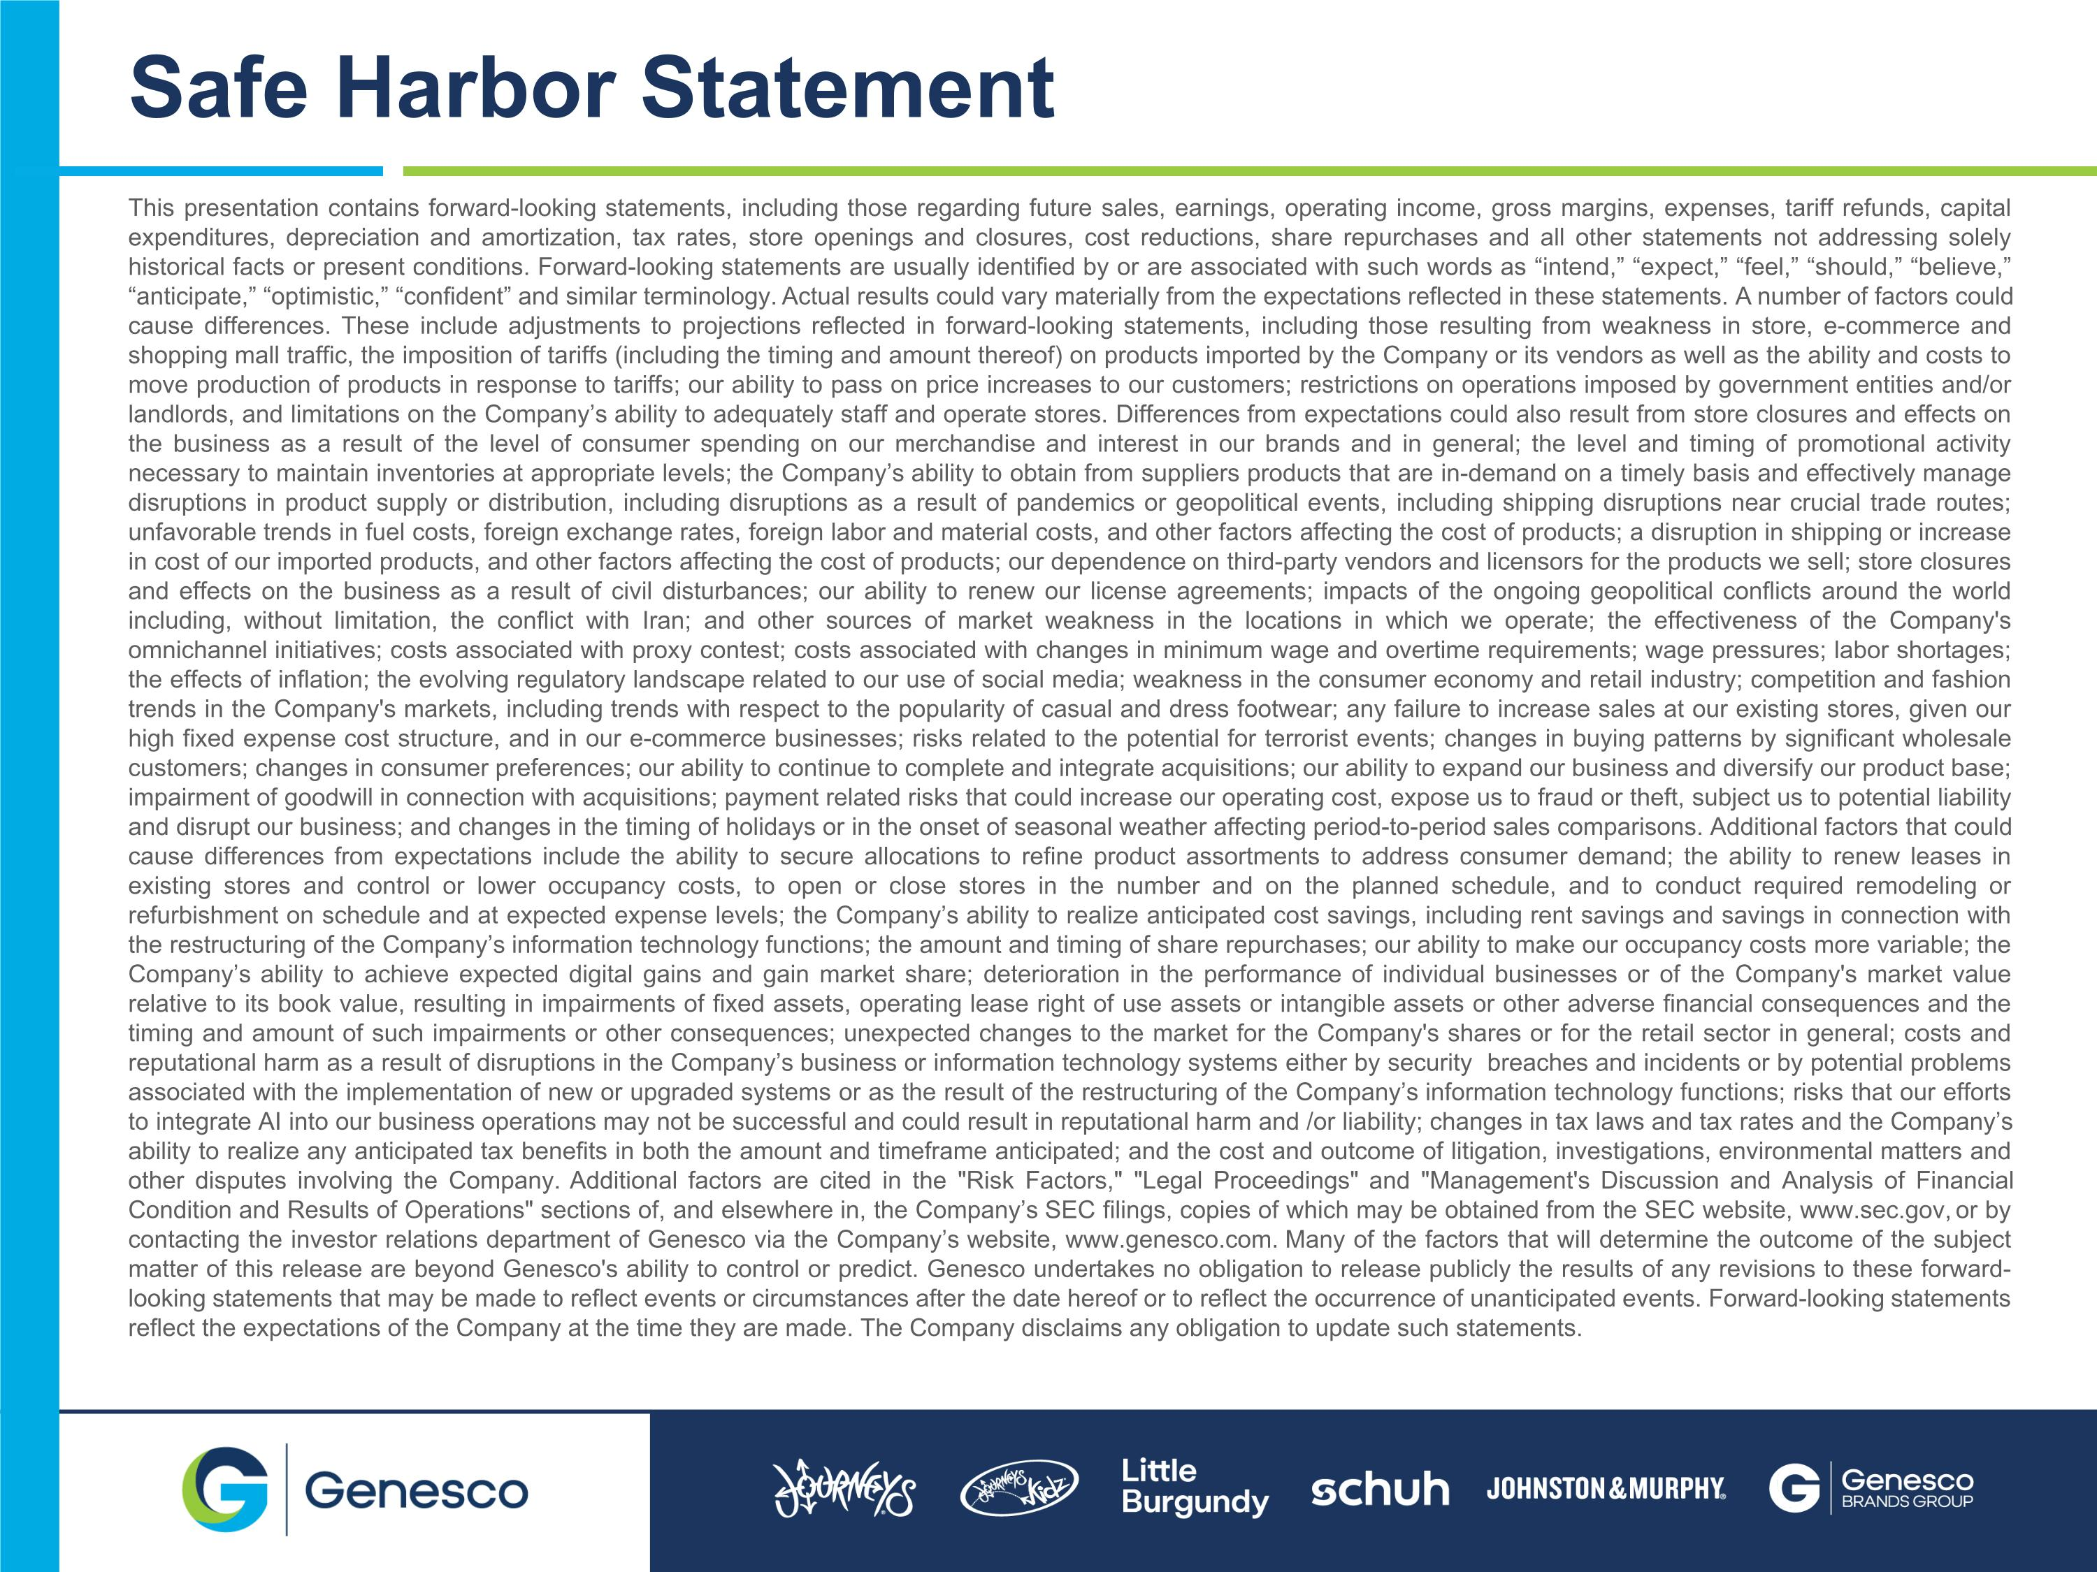
This presentation contains forward-looking statements, including those regarding future sales, earnings, operating income, gross margins, expenses, tariff refunds, capital expenditures, depreciation and amortization, tax rates, store openings and closures, cost reductions, share repurchases and all other statements not addressing solely historical facts or present conditions. Forward-looking statements are usually identified by or are associated with such words as “intend,” “expect,” “feel,” “should,” “believe,” “anticipate,” “optimistic,” “confident” and similar terminology. Actual results could vary materially from the expectations reflected in these statements. A number of factors could cause differences. These include adjustments to projections reflected in forward-looking statements, including those resulting from weakness in store, e-commerce and shopping mall traffic, the imposition of tariffs (including the timing and amount thereof) on products imported by the Company or its vendors as well as the ability and costs to move production of products in response to tariffs; our ability to pass on price increases to our customers; restrictions on operations imposed by government entities and/or landlords, and limitations on the Company’s ability to adequately staff and operate stores. Differences from expectations could also result from store closures and effects on the business as a result of the level of consumer spending on our merchandise and interest in our brands and in general; the level and timing of promotional activity necessary to maintain inventories at appropriate levels; the Company’s ability to obtain from suppliers products that are in-demand on a timely basis and effectively manage disruptions in product supply or distribution, including disruptions as a result of pandemics or geopolitical events, including shipping disruptions near crucial trade routes; unfavorable trends in fuel costs, foreign exchange rates, foreign labor and material costs, and other factors affecting the cost of products; a disruption in shipping or increase in cost of our imported products, and other factors affecting the cost of products; our dependence on third-party vendors and licensors for the products we sell; store closures and effects on the business as a result of civil disturbances; our ability to renew our license agreements; impacts of the ongoing geopolitical conflicts around the world including, without limitation, the conflict with Iran; and other sources of market weakness in the locations in which we operate; the effectiveness of the Company's omnichannel initiatives; costs associated with proxy contest; costs associated with changes in minimum wage and overtime requirements; wage pressures; labor shortages; the effects of inflation; the evolving regulatory landscape related to our use of social media; weakness in the consumer economy and retail industry; competition and fashion trends in the Company's markets, including trends with respect to the popularity of casual and dress footwear; any failure to increase sales at our existing stores, given our high fixed expense cost structure, and in our e-commerce businesses; risks related to the potential for terrorist events; changes in buying patterns by significant wholesale customers; changes in consumer preferences; our ability to continue to complete and integrate acquisitions; our ability to expand our business and diversify our product base; impairment of goodwill in connection with acquisitions; payment related risks that could increase our operating cost, expose us to fraud or theft, subject us to potential liability and disrupt our business; and changes in the timing of holidays or in the onset of seasonal weather affecting period-to-period sales comparisons. Additional factors that could cause differences from expectations include the ability to secure allocations to refine product assortments to address consumer demand; the ability to renew leases in existing stores and control or lower occupancy costs, to open or close stores in the number and on the planned schedule, and to conduct required remodeling or refurbishment on schedule and at expected expense levels; the Company’s ability to realize anticipated cost savings, including rent savings and savings in connection with the restructuring of the Company’s information technology functions; the amount and timing of share repurchases; our ability to make our occupancy costs more variable; the Company’s ability to achieve expected digital gains and gain market share; deterioration in the performance of individual businesses or of the Company's market value relative to its book value, resulting in impairments of fixed assets, operating lease right of use assets or intangible assets or other adverse financial consequences and the timing and amount of such impairments or other consequences; unexpected changes to the market for the Company's shares or for the retail sector in general; costs and reputational harm as a result of disruptions in the Company’s business or information technology systems either by security breaches and incidents or by potential problems associated with the implementation of new or upgraded systems or as the result of the restructuring of the Company’s information technology functions; risks that our efforts to integrate AI into our business operations may not be successful and could result in reputational harm and /or liability; changes in tax laws and tax rates and the Company’s ability to realize any anticipated tax benefits in both the amount and timeframe anticipated; and the cost and outcome of litigation, investigations, environmental matters and other disputes involving the Company. Additional factors are cited in the "Risk Factors," "Legal Proceedings" and "Management's Discussion and Analysis of Financial Condition and Results of Operations" sections of, and elsewhere in, the Company’s SEC filings, copies of which may be obtained from the SEC website, www.sec.gov, or by contacting the investor relations department of Genesco via the Company’s website, www.genesco.com. Many of the factors that will determine the outcome of the subject matter of this release are beyond Genesco's ability to control or predict. Genesco undertakes no obligation to release publicly the results of any revisions to these forward-looking statements that may be made to reflect events or circumstances after the date hereof or to reflect the occurrence of unanticipated events. Forward-looking statements reflect the expectations of the Company at the time they are made. The Company disclaims any obligation to update such statements. Safe Harbor Statement

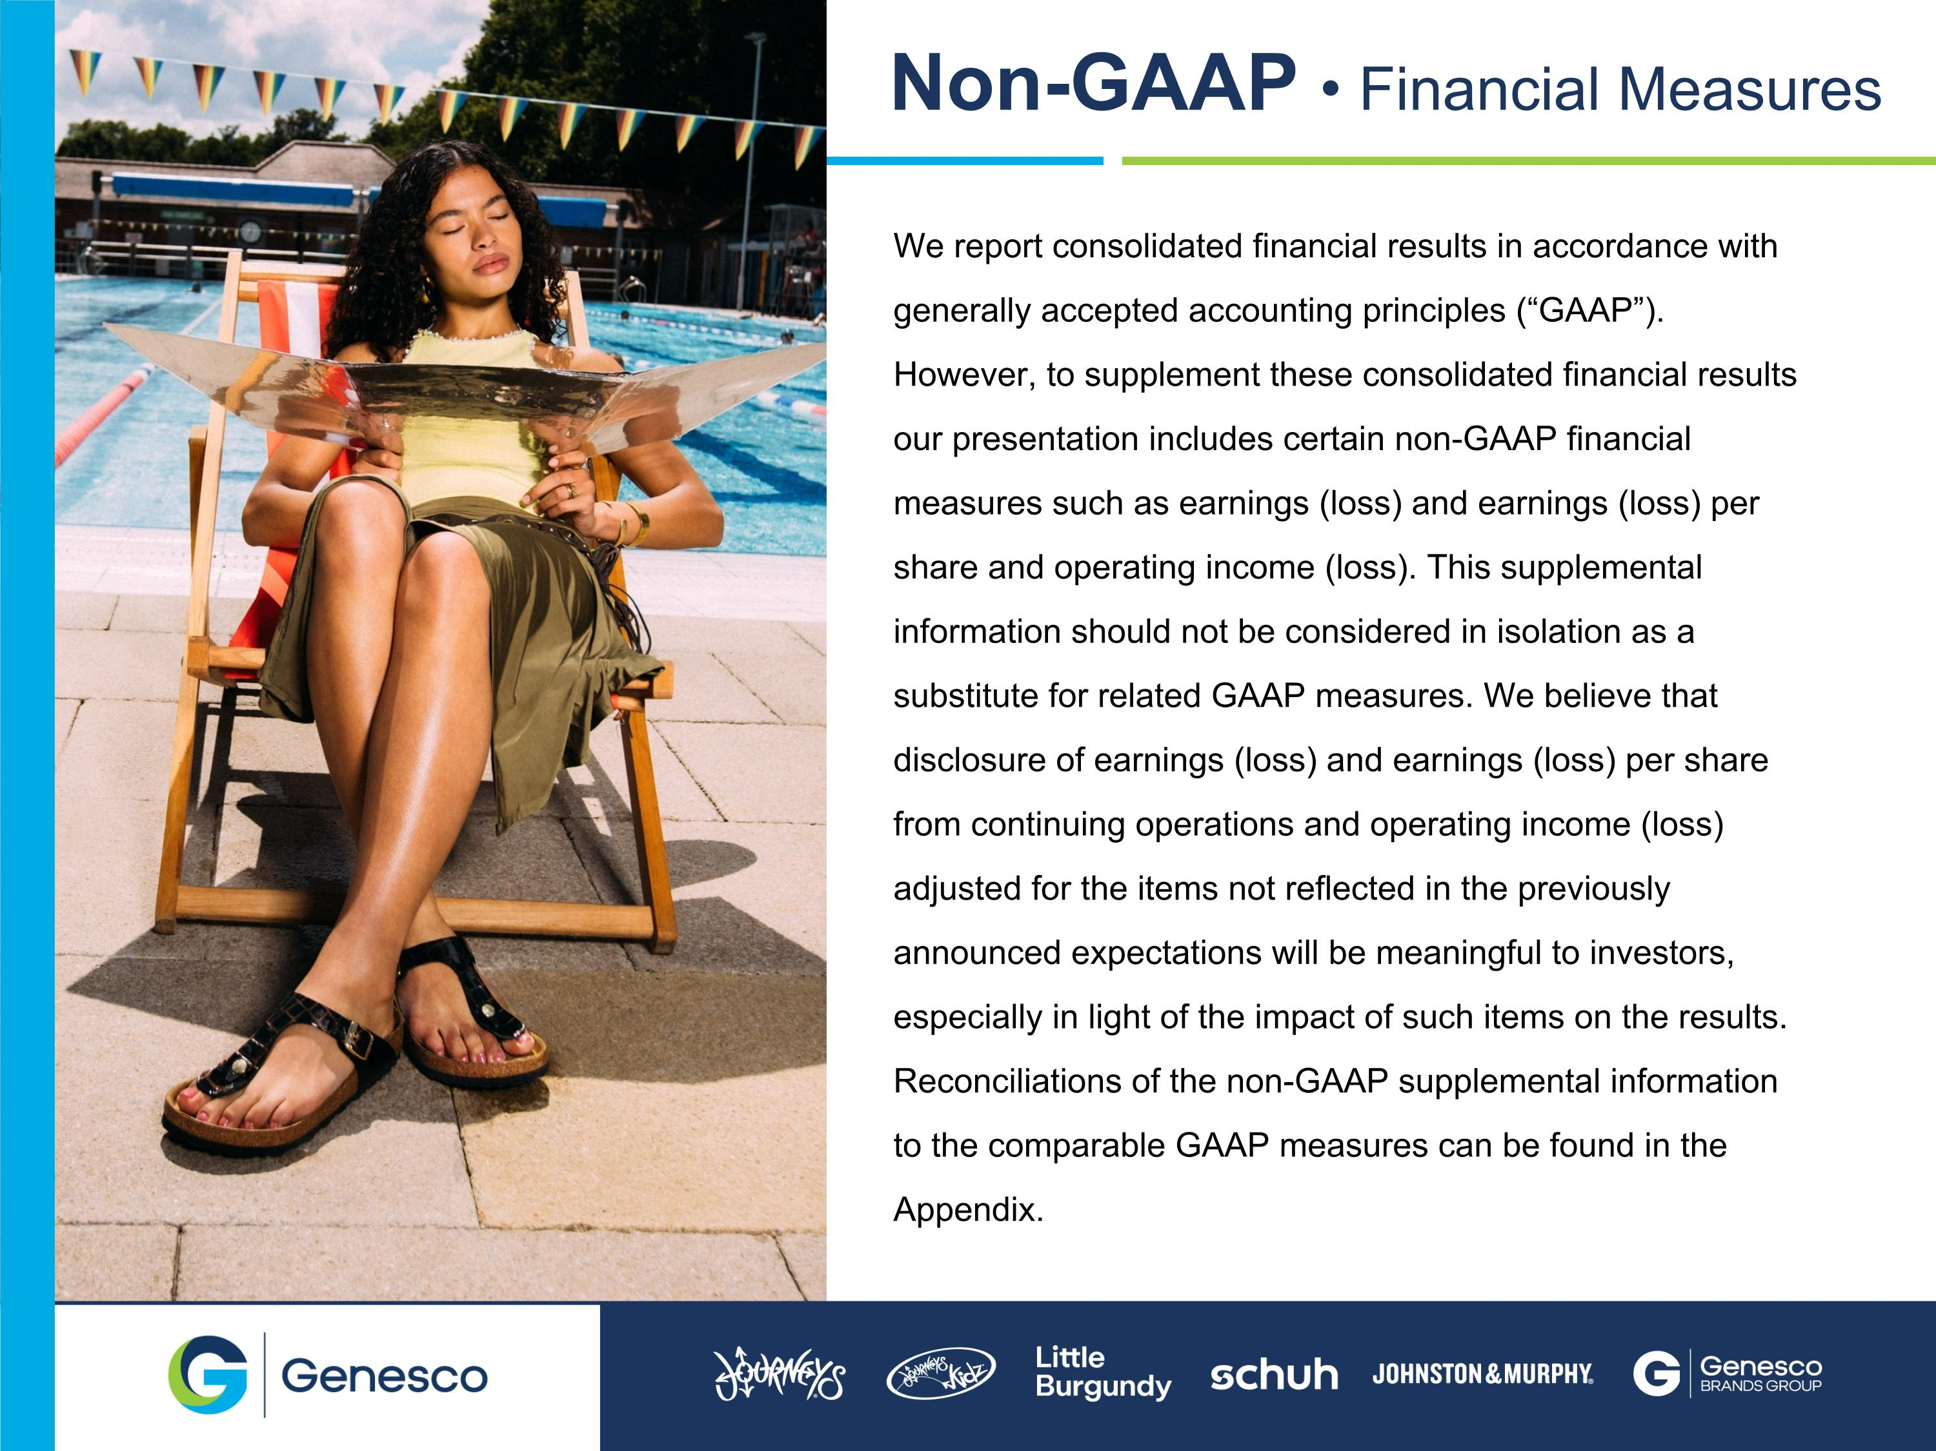
We report consolidated financial results in accordance with generally accepted accounting principles (“GAAP”). However, to supplement these consolidated financial results our presentation includes certain non-GAAP financial measures such as earnings (loss) and earnings (loss) per share and operating income (loss). This supplemental information should not be considered in isolation as a substitute for related GAAP measures. We believe that disclosure of earnings (loss) and earnings (loss) per share from continuing operations and operating income (loss) adjusted for the items not reflected in the previously announced expectations will be meaningful to investors, especially in light of the impact of such items on the results. Reconciliations of the non-GAAP supplemental information to the comparable GAAP measures can be found in the Appendix. Non-GAAP  Financial Measures

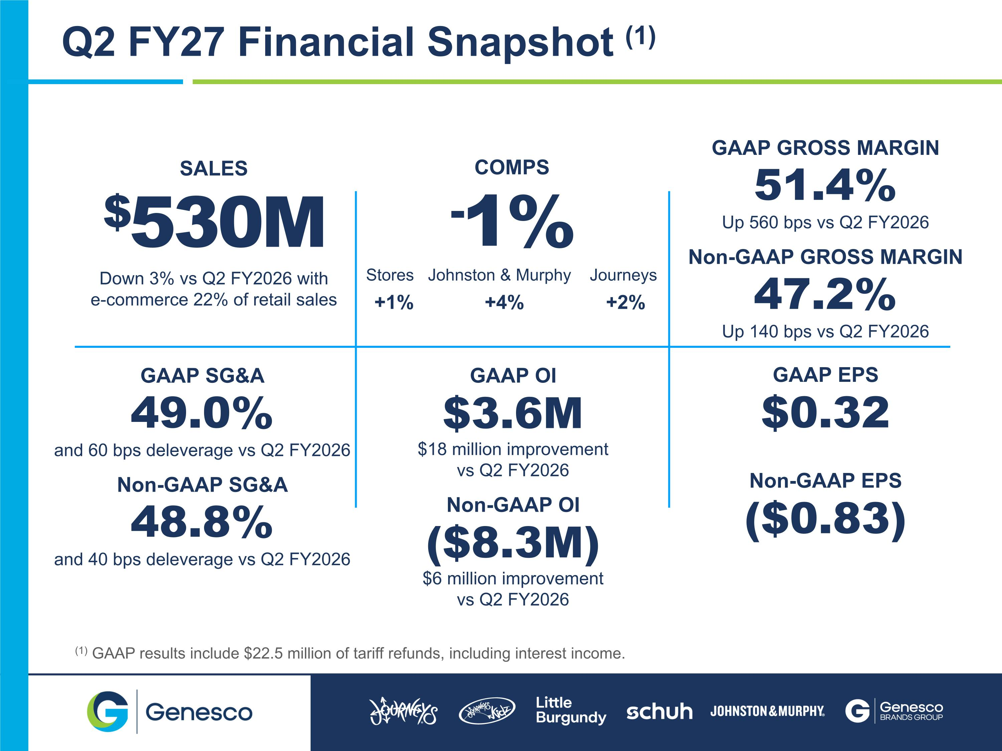
SALES $530M Down 3% vs Q2 FY2026 with ?e-commerce 22% of retail sales GAAP SG&A 49.0% and 60 bps deleverage vs Q2 FY2026 Non-GAAP SG&A 48.8% and 40 bps deleverage vs Q2 FY2026 COMPS -1% Stores Johnston & Murphy Journeys +1% +4% +2% GAAP OI $3.6M $18 million improvement vs Q2 FY2026 Non-GAAP OI ($8.3M) $6 million improvement vs Q2 FY2026 Q2 FY27 Financial Snapshot (1) GAAP GROSS MARGIN 51.4% Up 560 bps vs Q2 FY2026 Non-GAAP GROSS MARGIN 47.2% Up 140 bps vs Q2 FY2026 GAAP EPS $0.32 Non-GAAP EPS ($0.83) (1) GAAP results include $22.5 million of tariff refunds, including interest income.

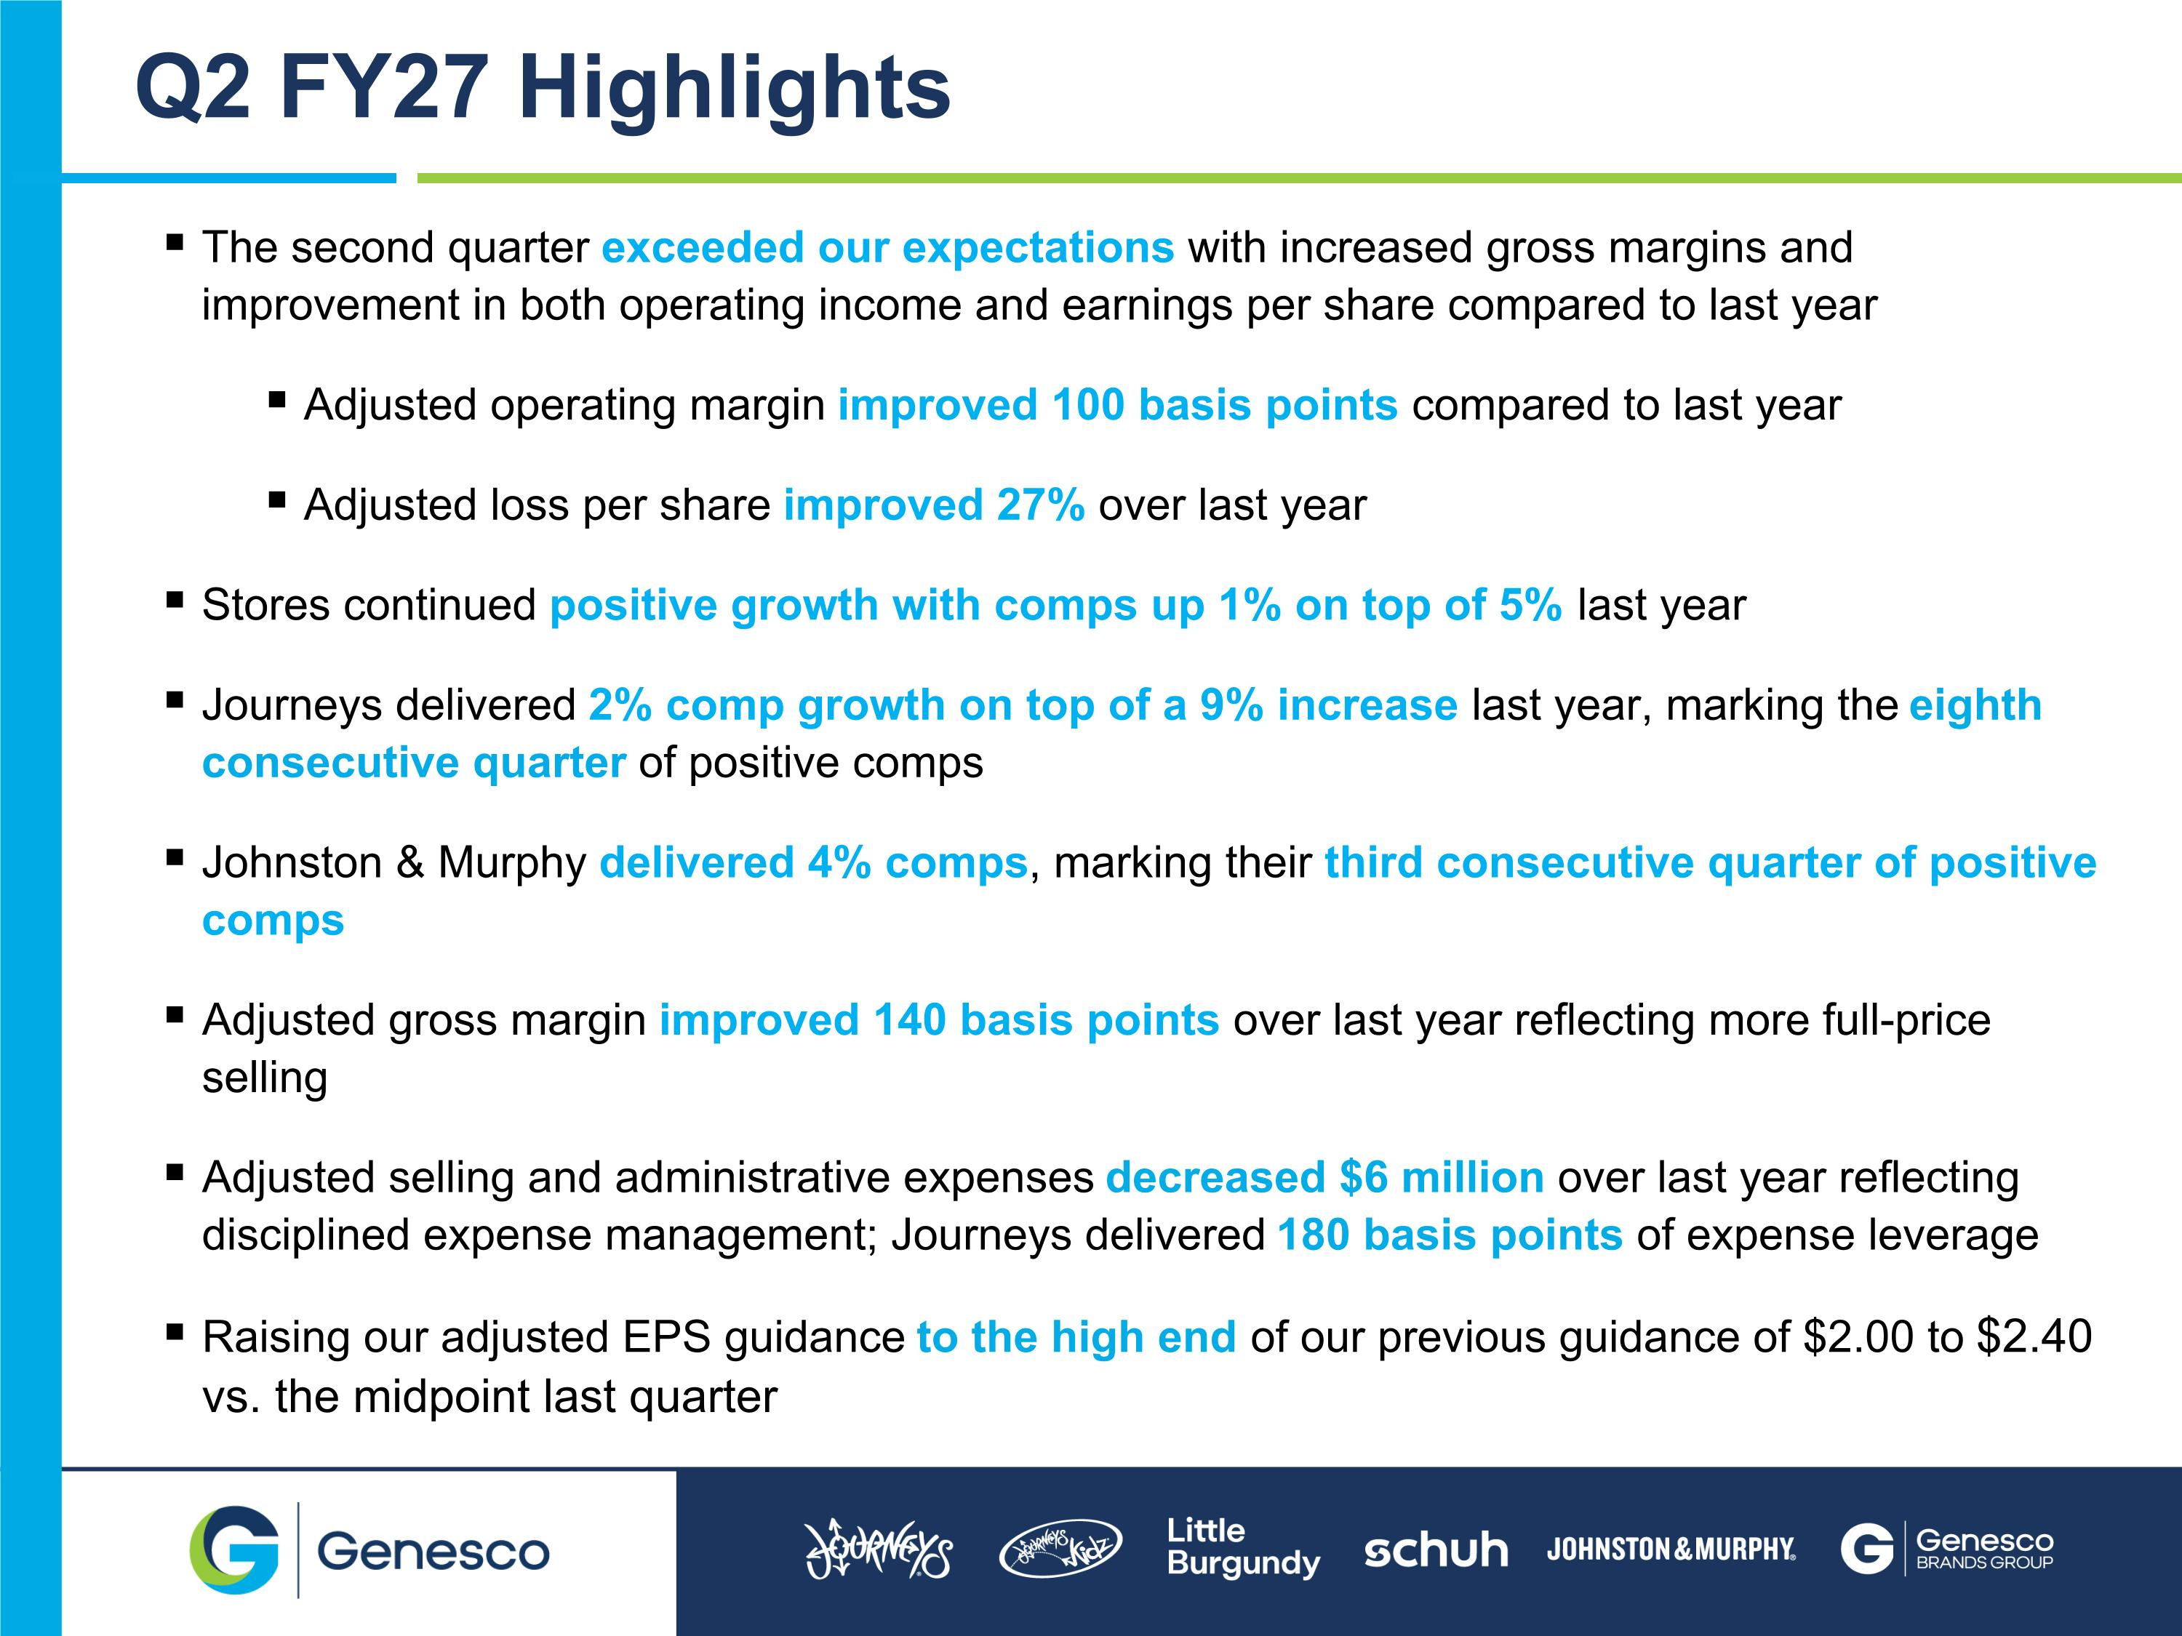
The second quarter exceeded our expectations with increased gross margins and improvement in both operating income and earnings per share compared to last year Adjusted operating margin improved 100 basis points compared to last year Adjusted loss per share improved 27% over last year Stores continued positive growth with comps up 1% on top of 5% last year Journeys delivered 2% comp growth on top of a 9% increase last year, marking the eighth consecutive quarter of positive comps Johnston & Murphy delivered 4% comps, marking their third consecutive quarter of positive comps Adjusted gross margin improved 140 basis points over last year reflecting more full-price selling Adjusted selling and administrative expenses decreased $6 million over last year reflecting disciplined expense management; Journeys delivered 180 basis points of expense leverage Raising our adjusted EPS guidance to the high end of our previous guidance of $2.00 to $2.40 vs. the midpoint last quarter Q2 FY27 Highlights

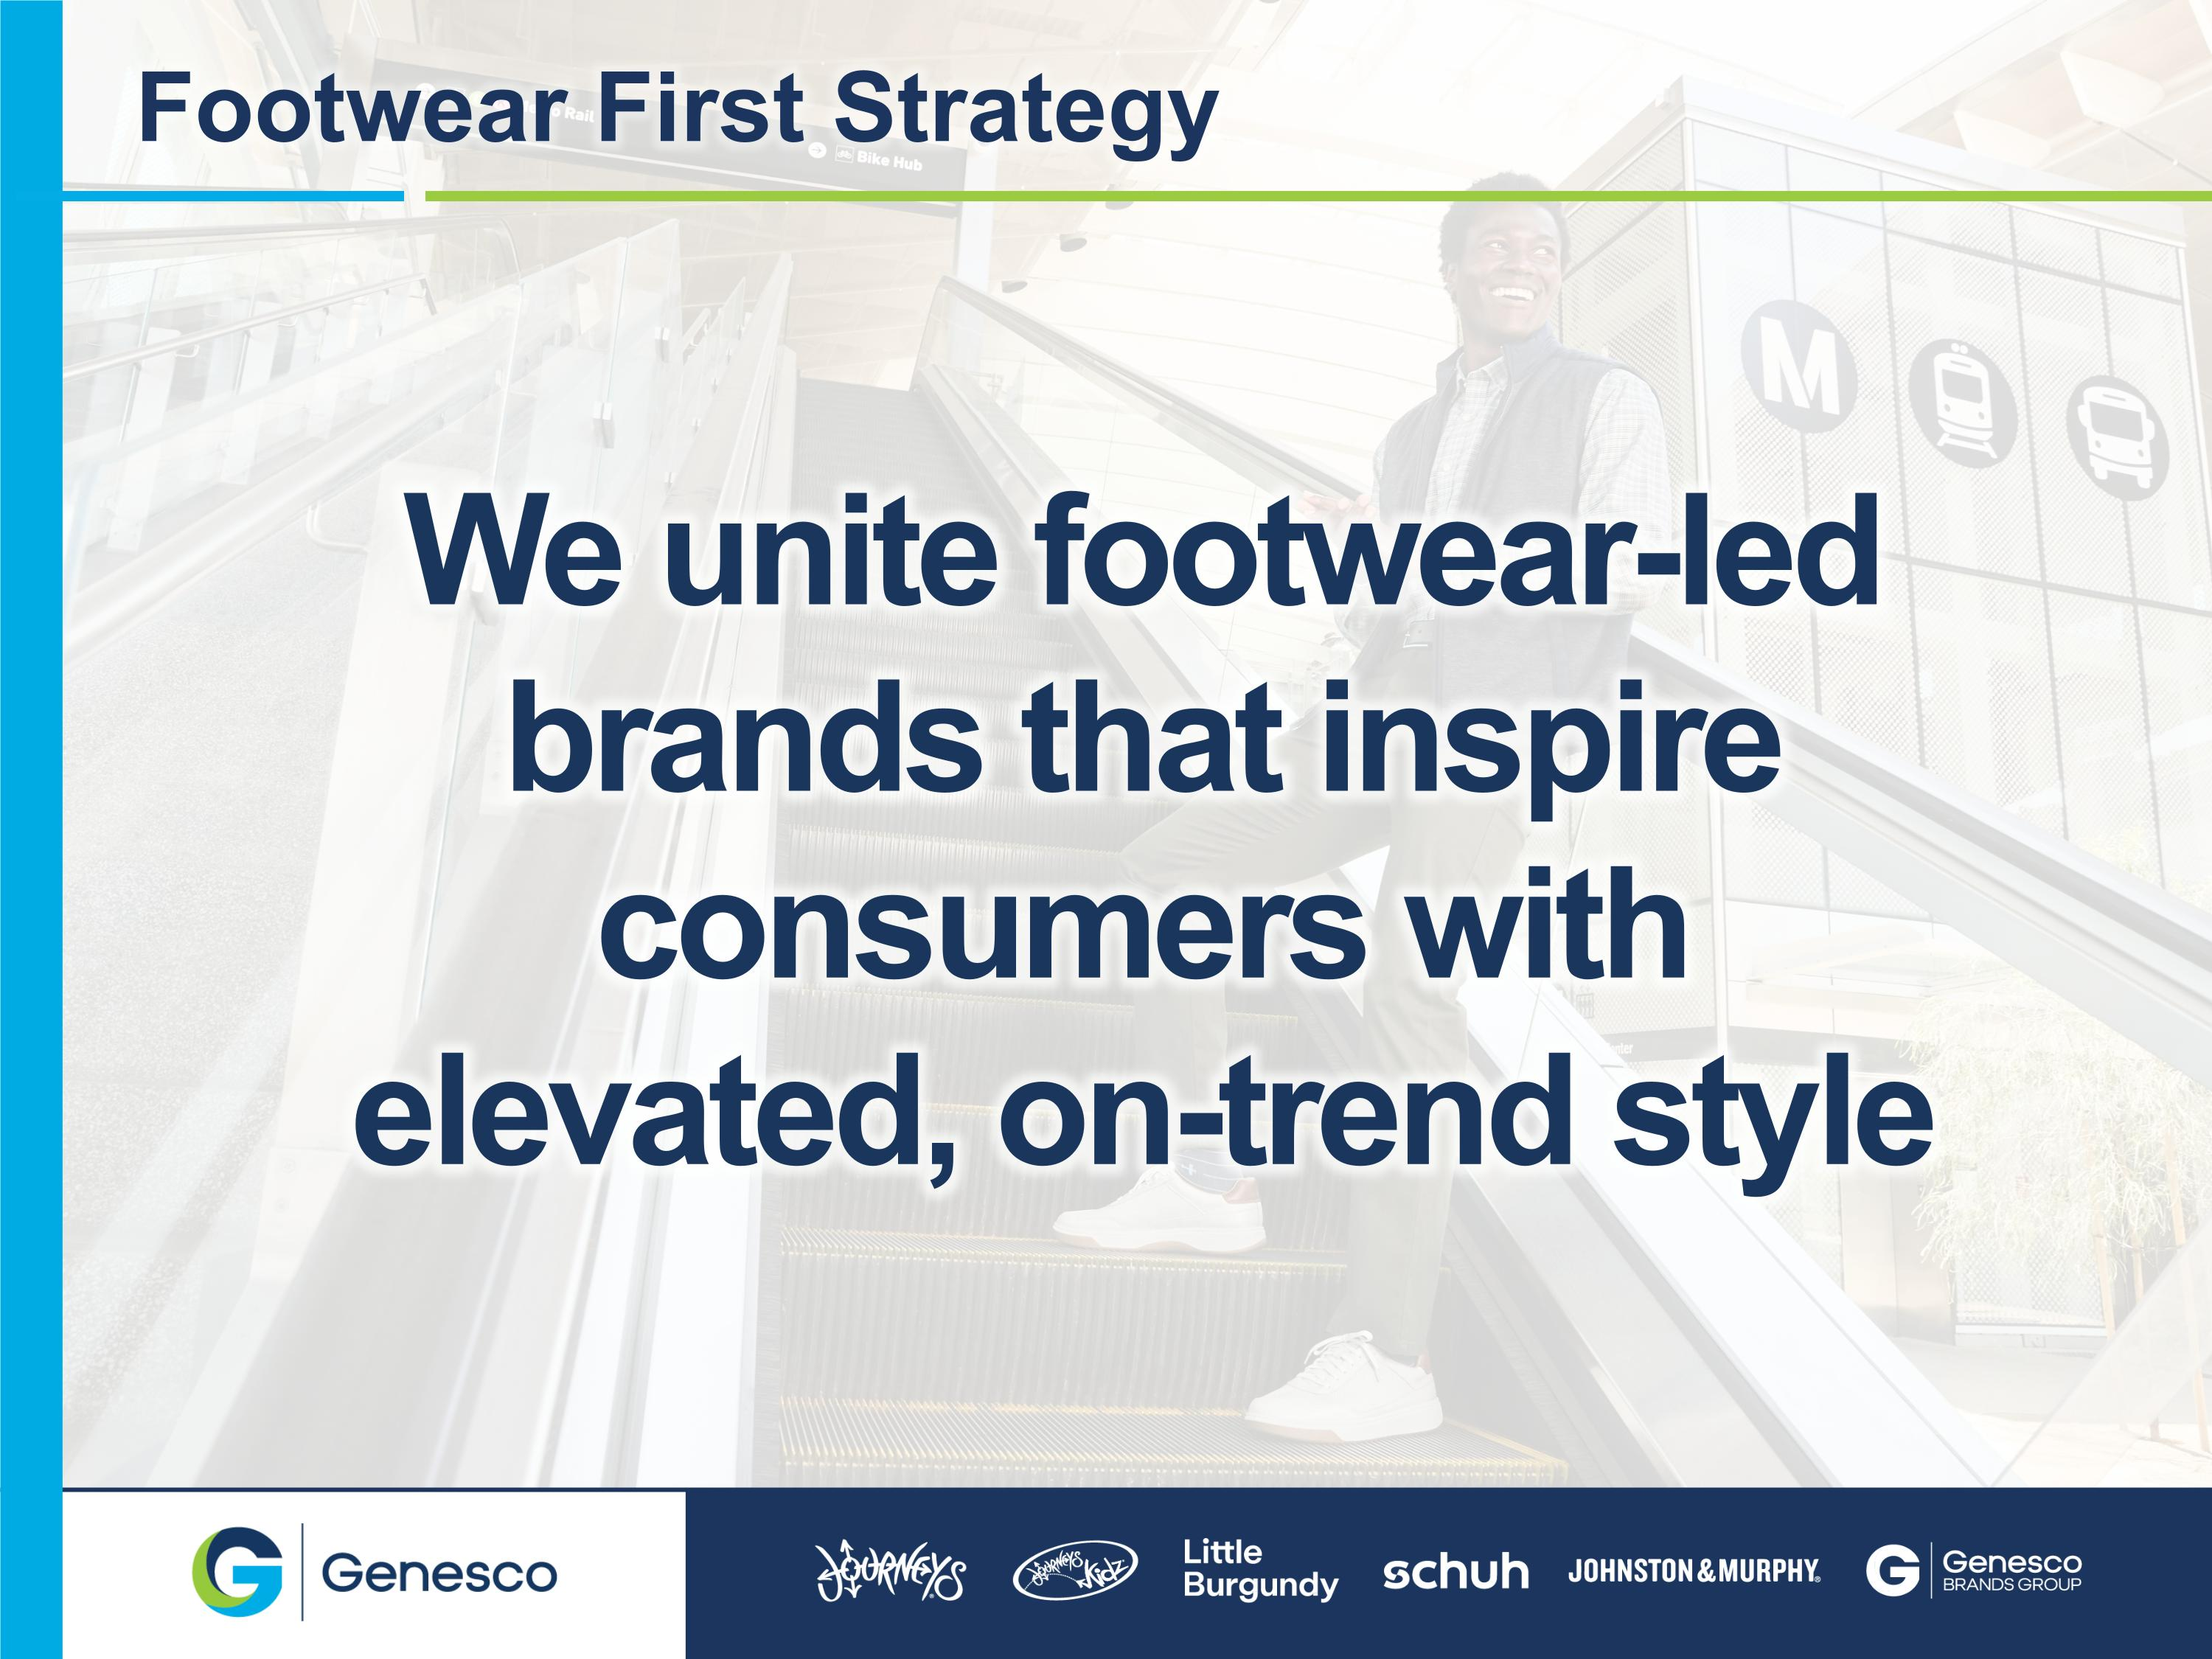
We unite footwear-led brands that inspire consumers with elevated, on-trend style Footwear First Strategy

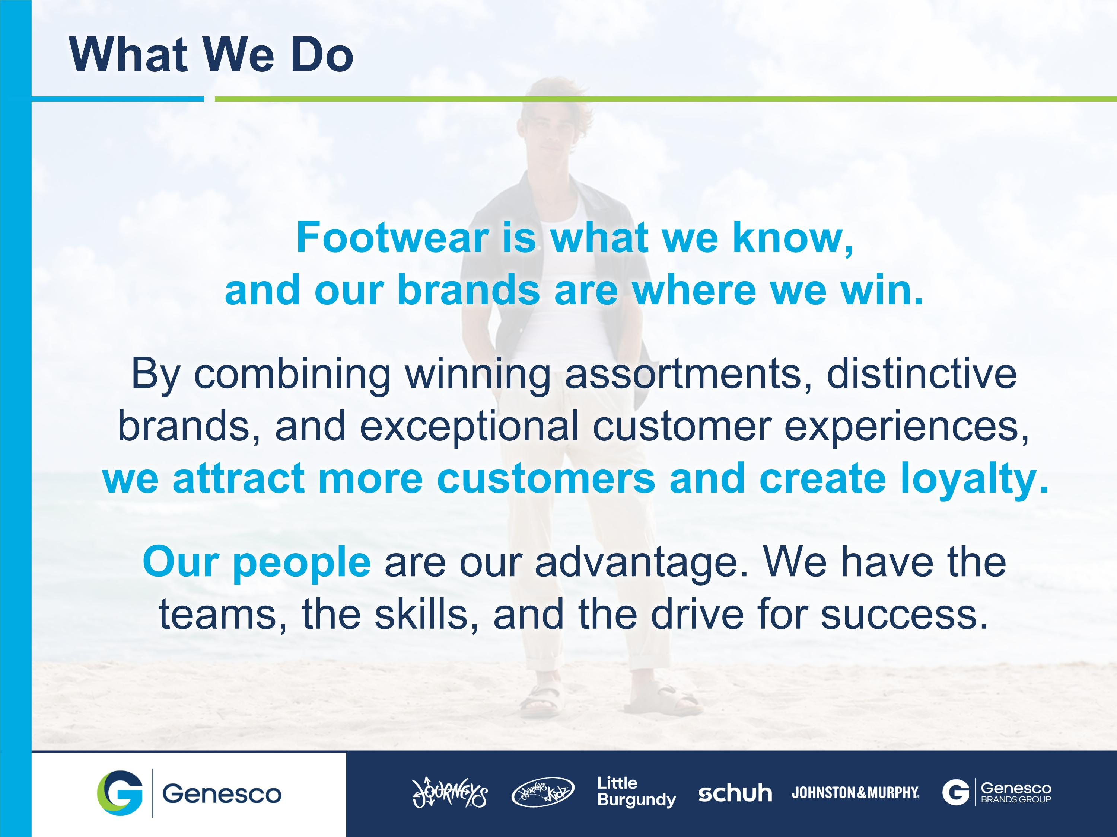
Footwear is what we know, ?and our brands are where we win. ??By combining winning assortments, distinctive brands, and exceptional customer experiences, we attract more customers and create loyalty.??Our people are our advantage. We have the teams, the skills, and the drive for success. What We Do

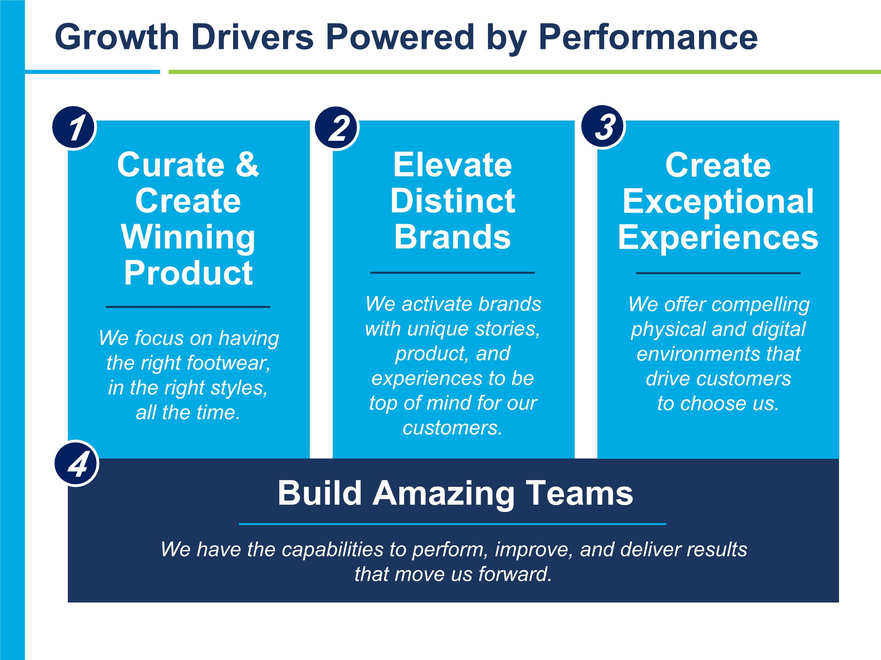
1 Curate & Create Winning Product We focus on having the right footwear, in the right styles, all the time. Elevate Distinct Brands We activate brands with unique stories, product, and experiences to be top of mind for our customers. Create Exceptional Experiences We offer compelling physical and digital environments that drive customers to choose us. Build Amazing Teams We have the capabilities to perform, improve, and deliver results that move us forward. Growth Drivers Powered by Performance 2 3 4


What is Journeys’ Strategic Growth Plan? Multi-Brand, multi-category offering to inspire the journey from one you to the next


Unique Consumer Positioning There is white space in the market for Journeys to expand its reach amongst teens with a sharp focus on females STYLE-LED FOOTWEAR DESTINATION

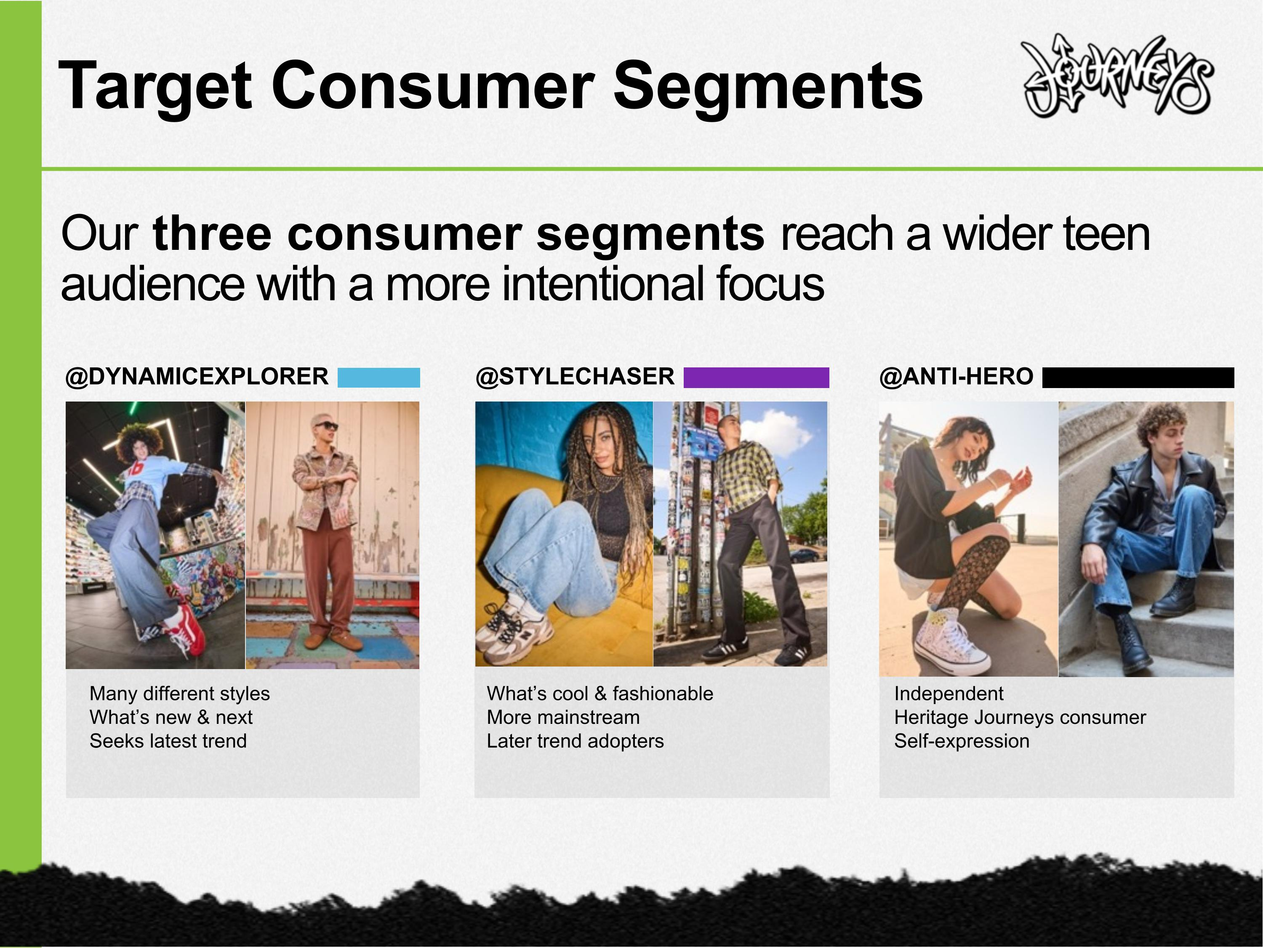
Our three consumer segments reach a wider teen audience with a more intentional focus Target Consumer Segments @STYLECHASER What’s cool & fashionable More mainstream Later trend adopters @ANTI-HERO Independent Heritage Journeys consumer Self-expression @DYNAMICEXPLORER Many different styles What’s new & next Seeks latest trend

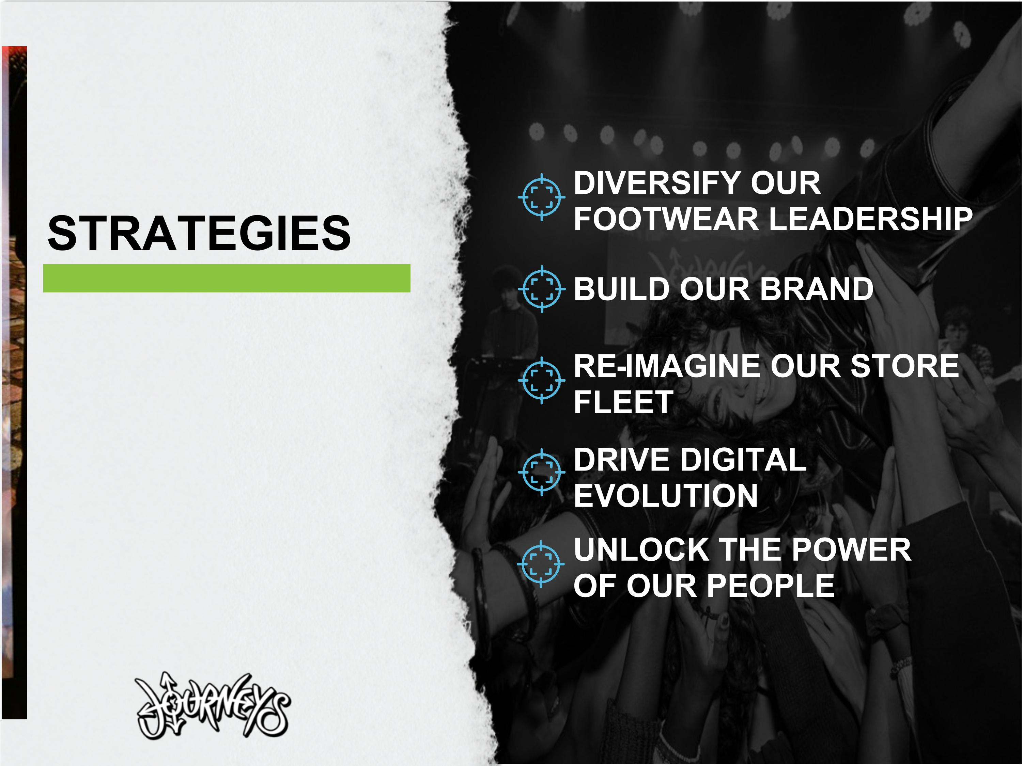
STRATEGIES DIVERSIFY OUR FOOTWEAR LEADERSHIP BUILD OUR BRAND RE-IMAGINE OUR STORE FLEET DRIVE DIGITAL EVOLUTION UNLOCK THE POWER OF OUR PEOPLE

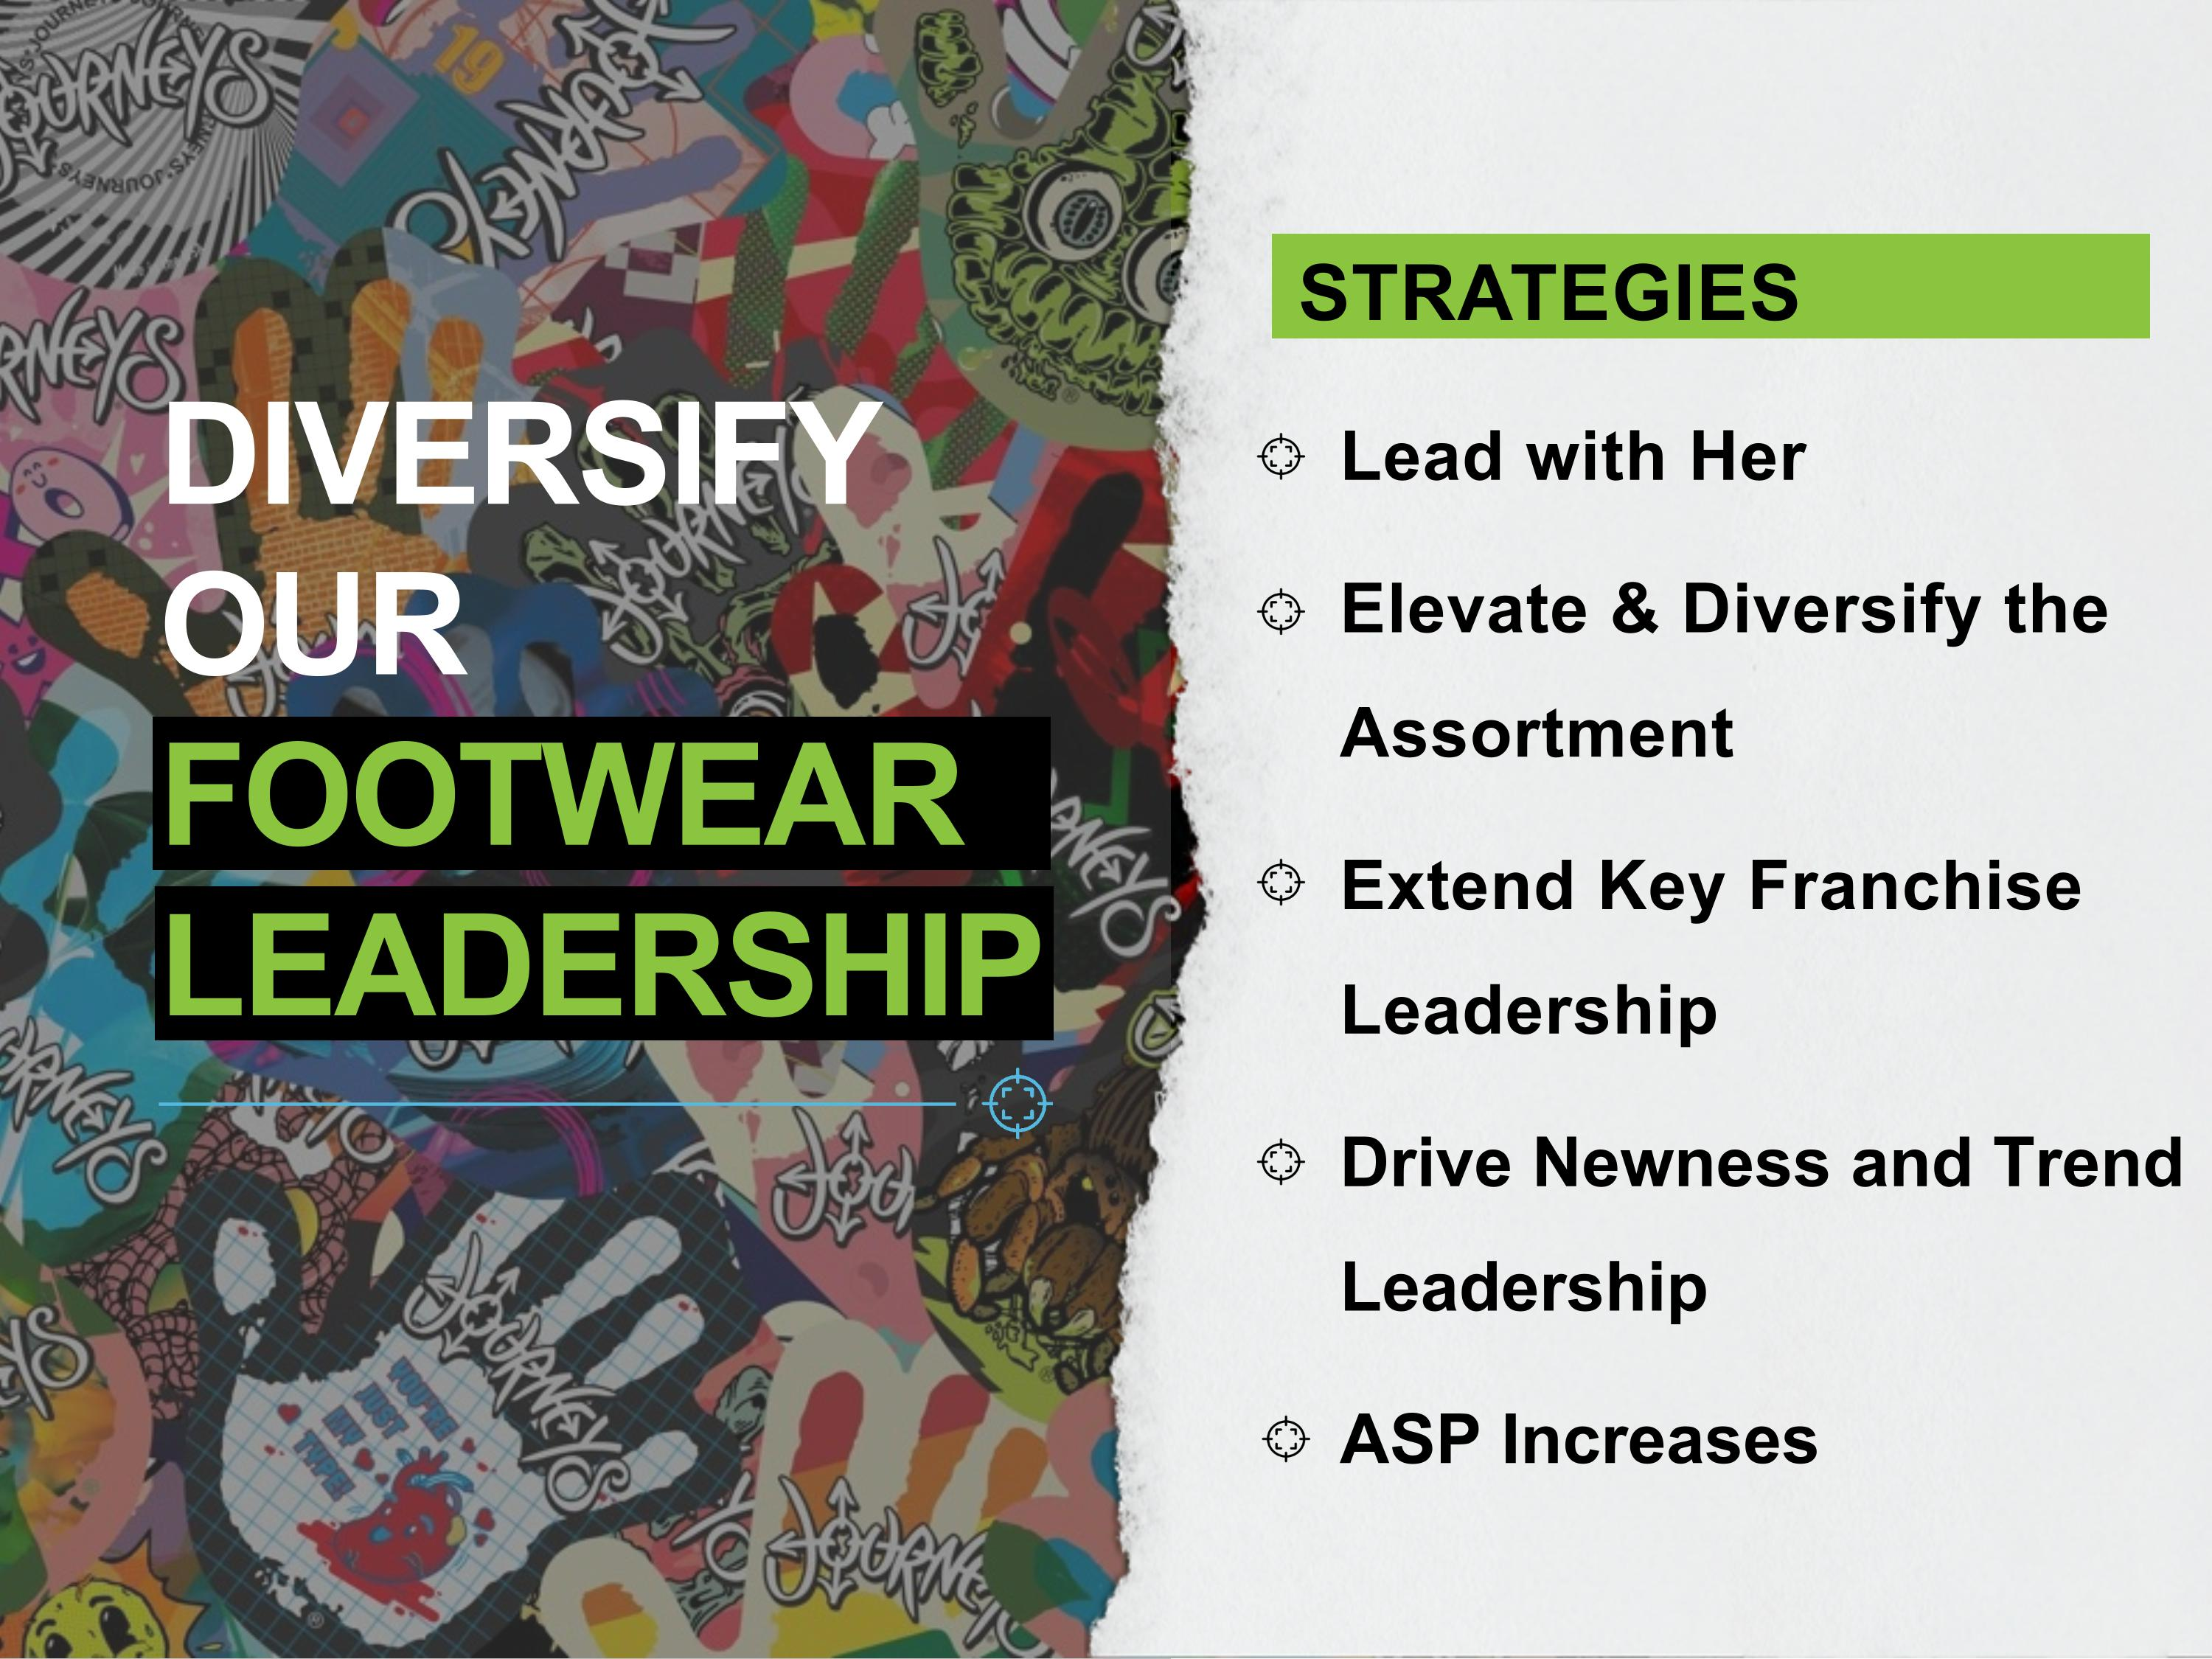
DIVERSIFY OUR FOOTWEAR LEADERSHIP STRATEGIES Lead with Her Elevate & Diversify the Assortment Extend Key Franchise Leadership Drive Newness and Trend Leadership ASP Increases


BUILD OUR BRAND STRATEGIES Life on Loud and New Creative Concept for BTS and Holiday Invest in Journeys Brand Presence for Greater Awareness Elevate Editorial Content and Trend Positioning Expand Brand Activation Launch Community Platform

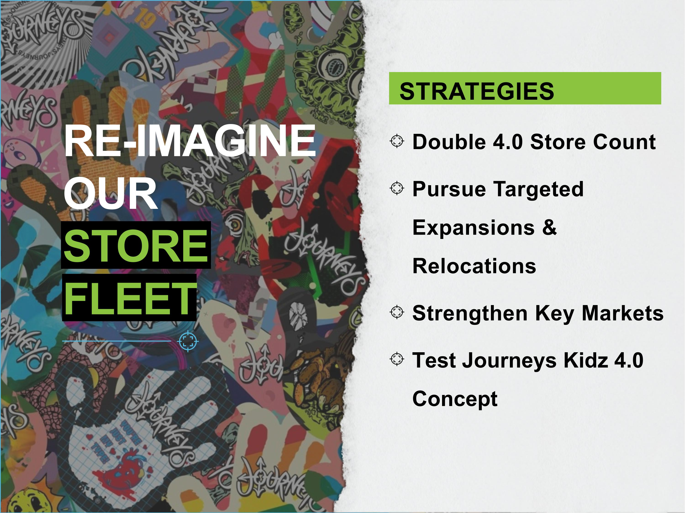
STRATEGIES Double 4.0 Store Count Pursue Targeted Expansions & Relocations Strengthen Key Markets Test Journeys Kidz 4.0 Concept RE-IMAGINE OUR STORE FLEET

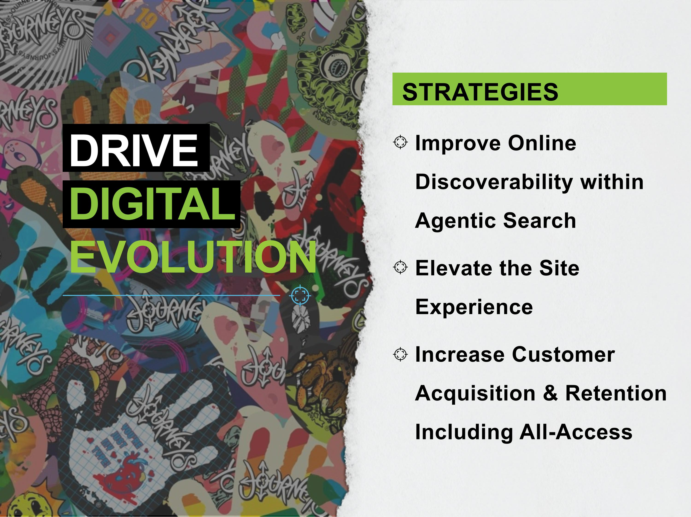
STRATEGIES Improve Online Discoverability within Agentic Search Elevate the Site Experience Increase Customer Acquisition & Retention Including All-Access DRIVE DIGITAL EVOLUTION


FINANCIALS

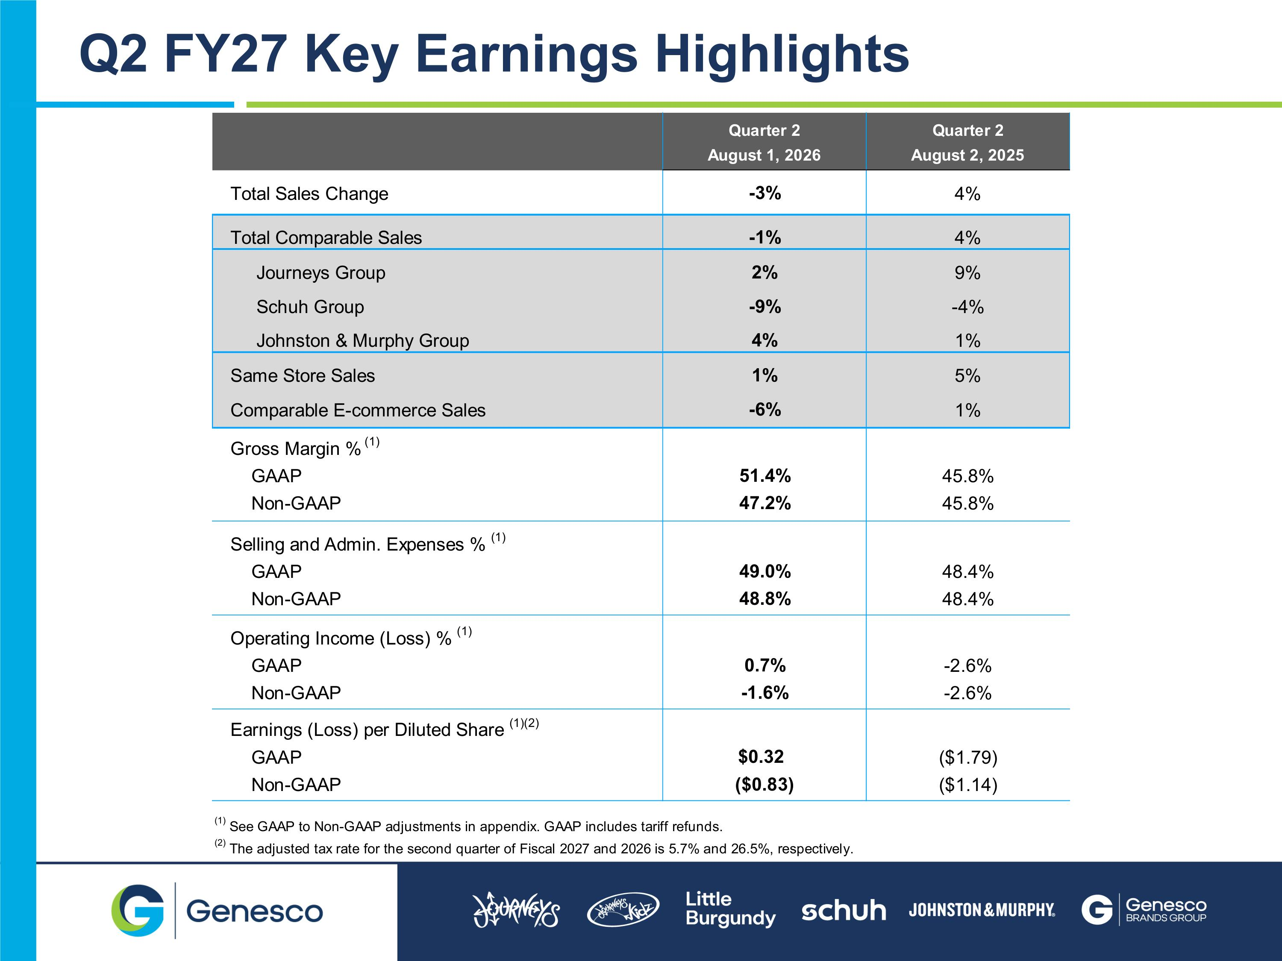
Q2 FY27 Key Earnings Highlights

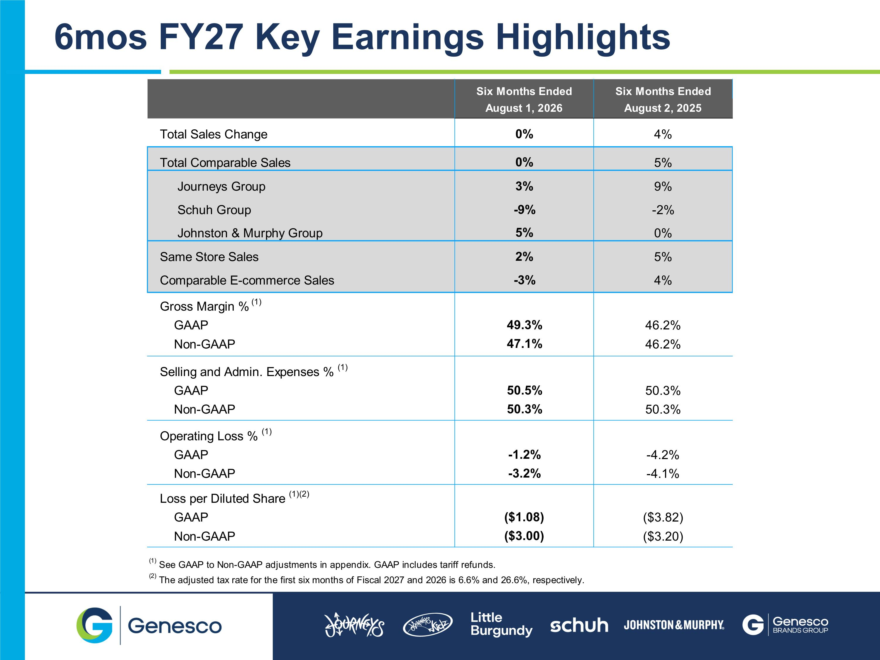
6mos FY27 Key Earnings Highlights

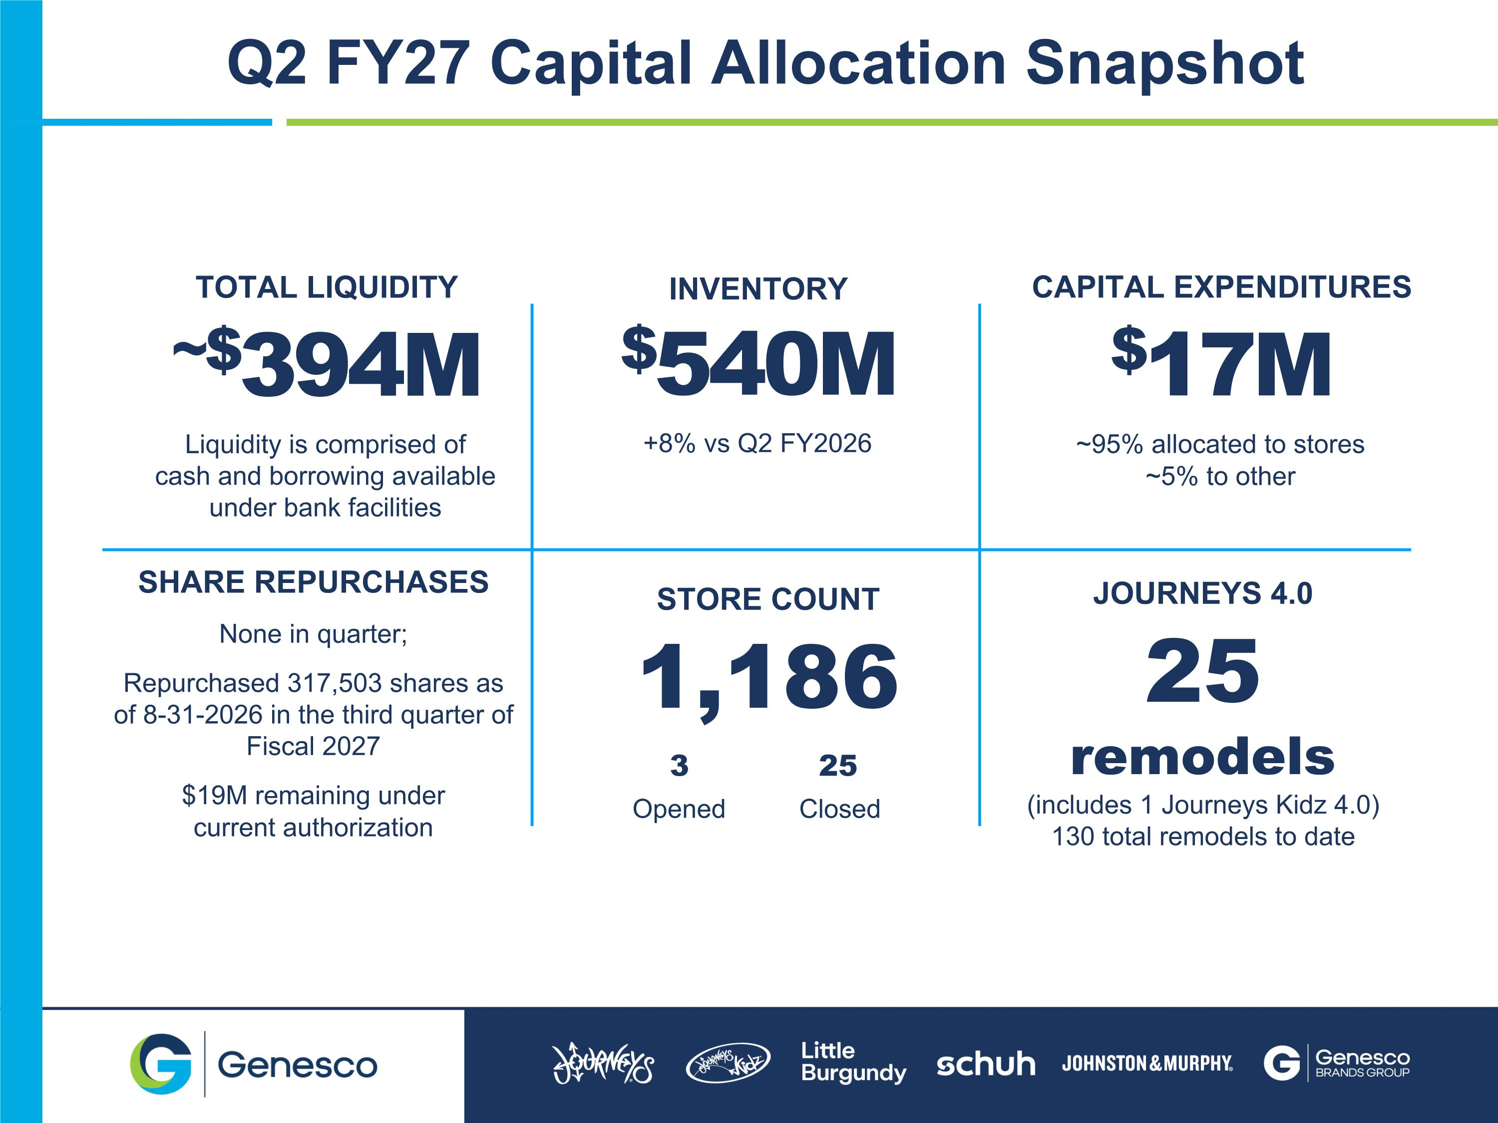
TOTAL LIQUIDITY ~$394M Liquidity is comprised of ?cash and borrowing available ?under bank facilities INVENTORY $540M +8% vs Q2 FY2026 CAPITAL EXPENDITURES $17M ~95% allocated to stores ~5% to other STORE COUNT 1,186 3 25 Opened Closed SHARE REPURCHASES None in quarter; Repurchased 317,503 shares as of 8-31-2026 in the third quarter of Fiscal 2027 $19M remaining under current authorization JOURNEYS 4.0 25 remodels (includes 1 Journeys Kidz 4.0) 130 total remodels to date Q2 FY27 Capital Allocation Snapshot

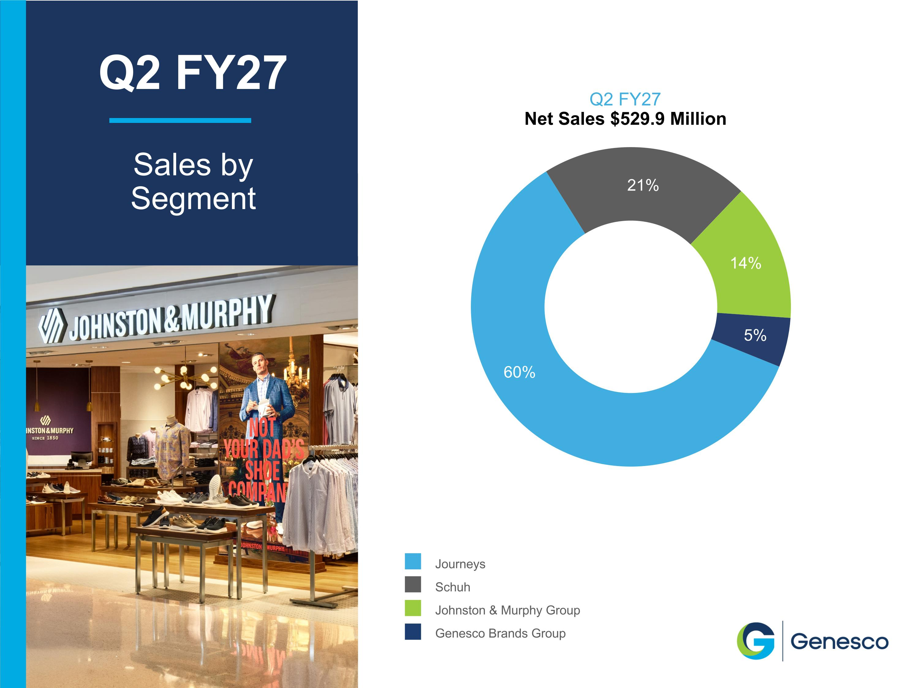
Q2 FY27 Net Sales $529.9 Million Journeys Schuh Johnston & Murphy Group Genesco Brands Group Q2 FY27 Sales by Segment

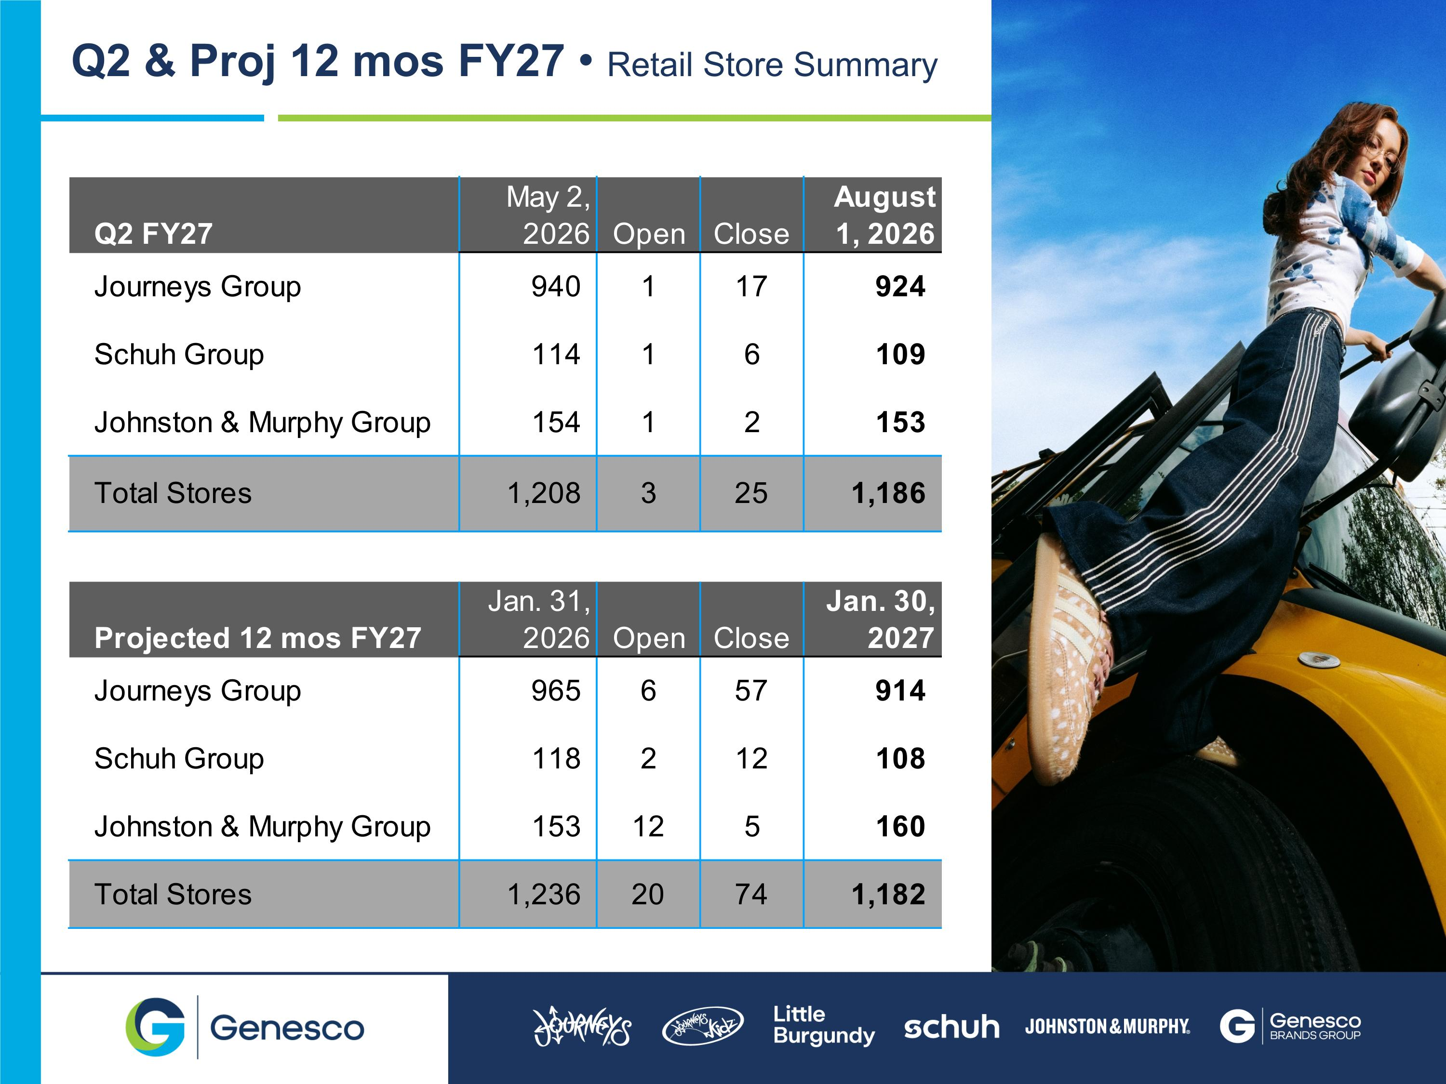
Q2 & Proj 12 mos FY27  Retail Store Summary

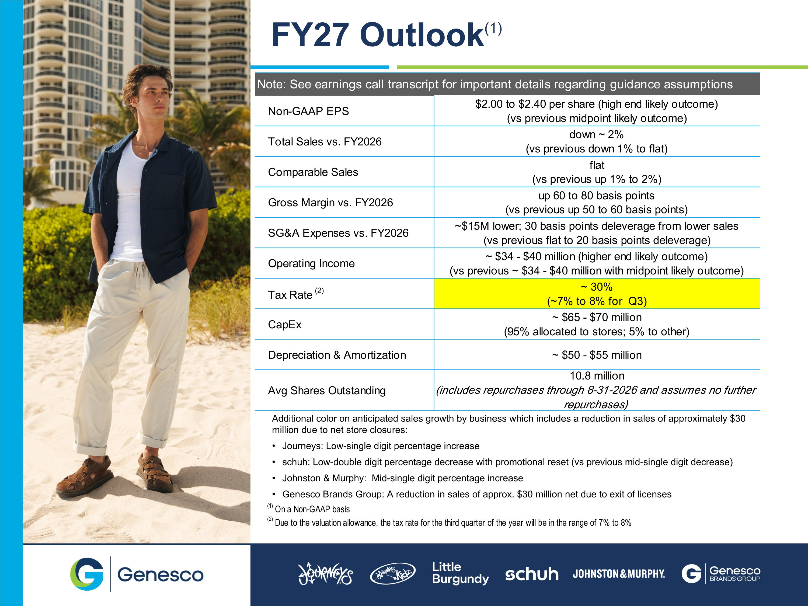
FY27 Outlook(1) Additional color on anticipated sales growth by business which includes a reduction in sales of approximately $30 million due to net store closures: Journeys: Low-single digit percentage increase schuh: Low-double digit percentage decrease with promotional reset (vs previous mid-single digit decrease) Johnston & Murphy: Mid-single digit percentage increase Genesco Brands Group: A reduction in sales of approx. $30 million net due to exit of licenses


APPENDIX

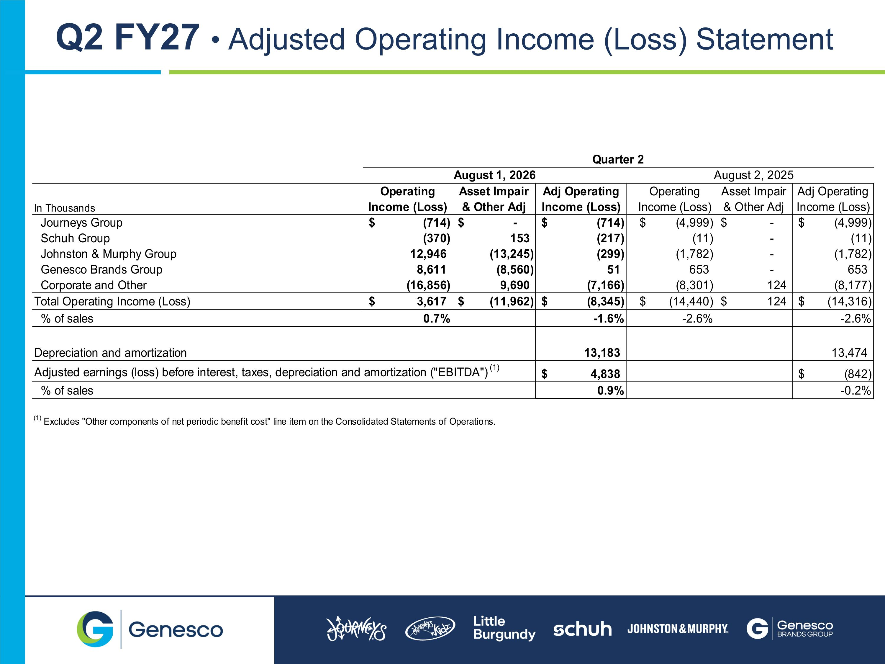
Q2 FY27  Adjusted Operating Income (Loss) Statement

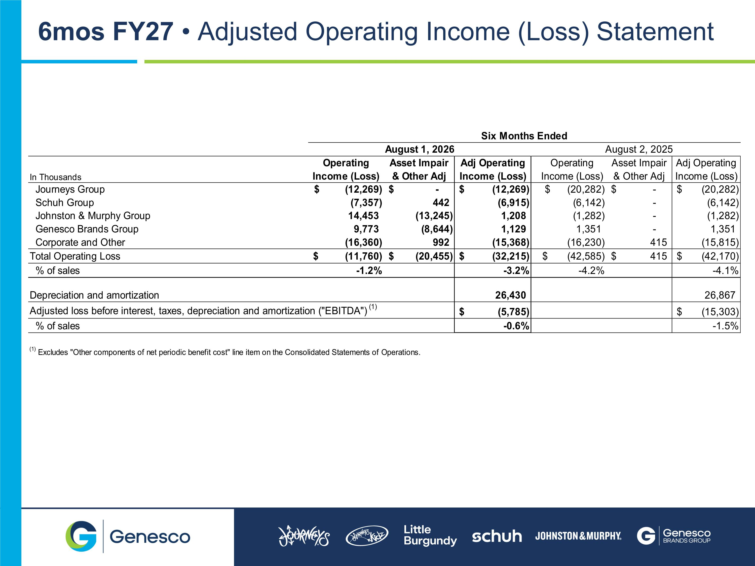
(1) 6mos FY27  Adjusted Operating Income (Loss) Statement

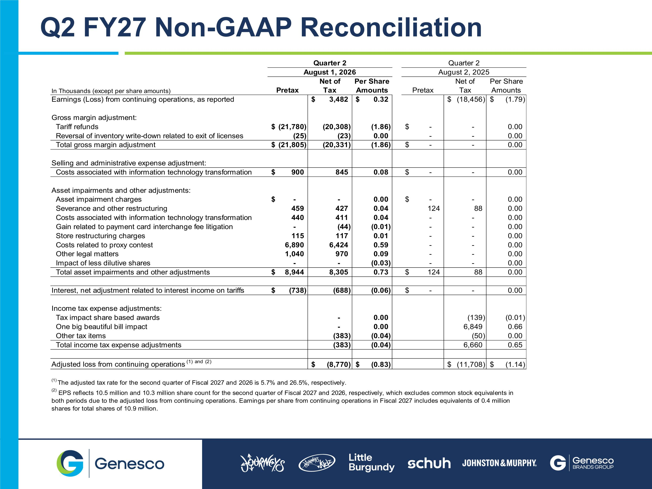
Q2 FY27 Non-GAAP Reconciliation

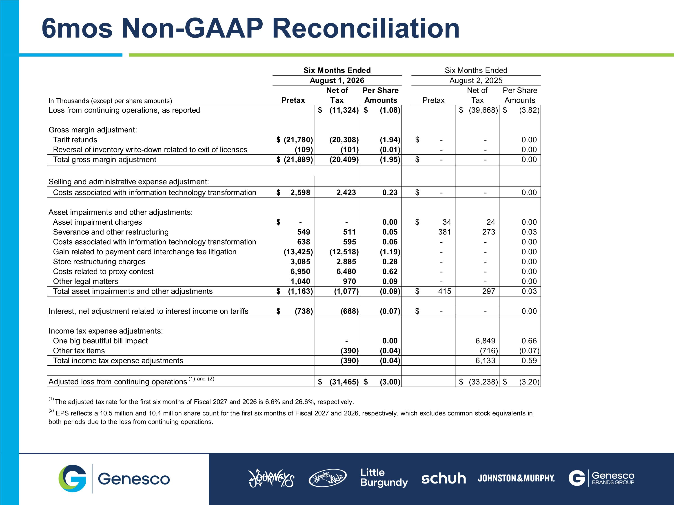
6mos Non-GAAP Reconciliation

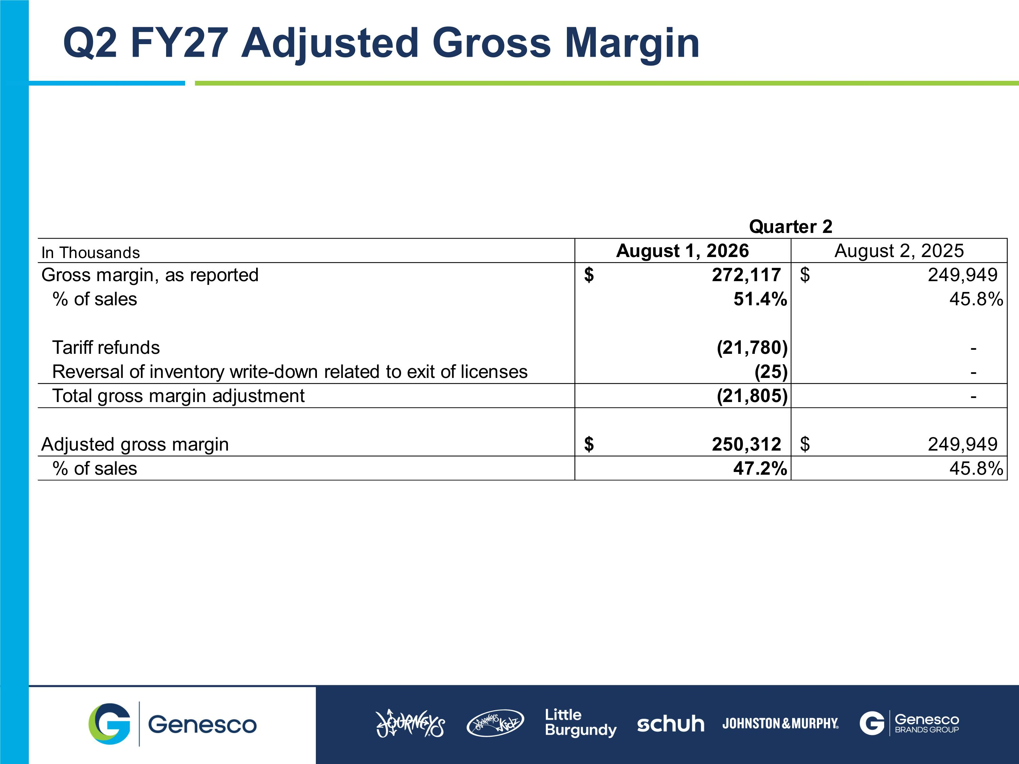
Q2 FY27 Adjusted Gross Margin

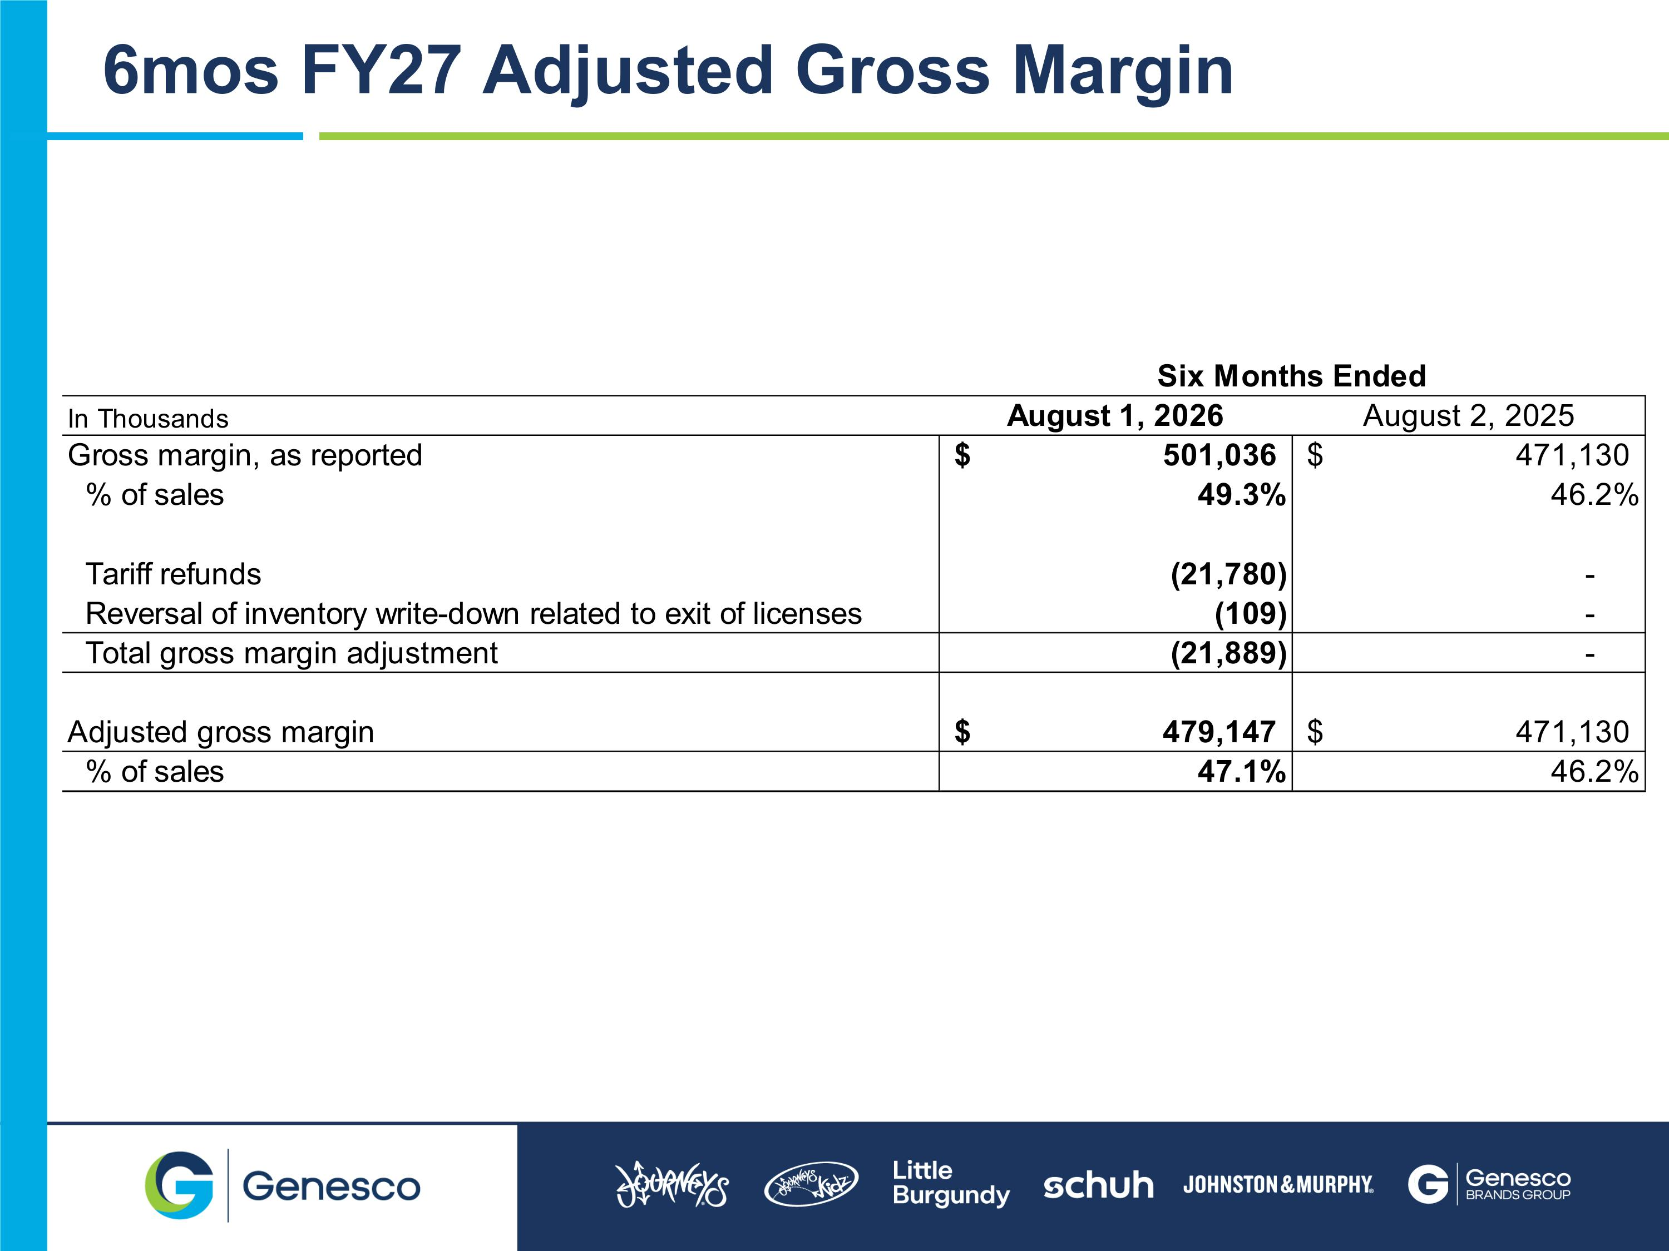
6mos FY27 Adjusted Gross Margin

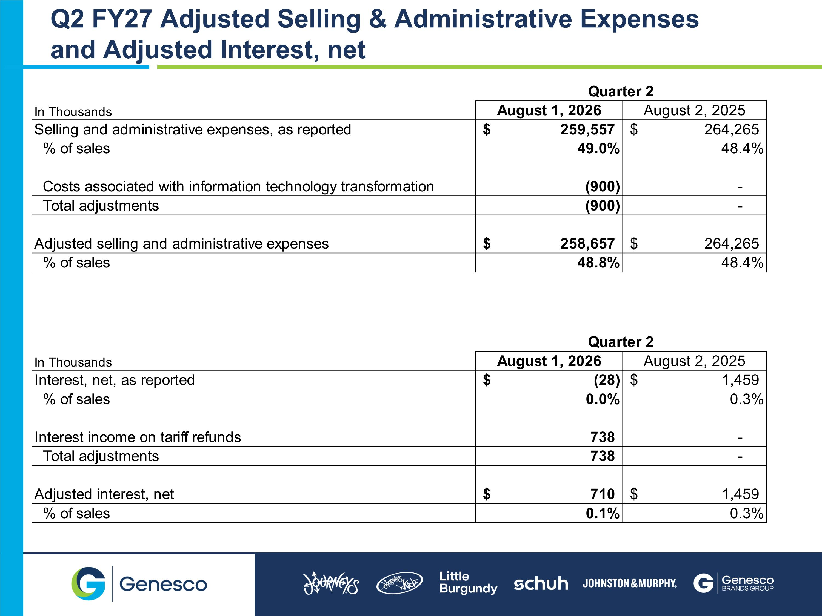
Q2 FY27 Adjusted Selling & Administrative Expenses and Adjusted Interest, net

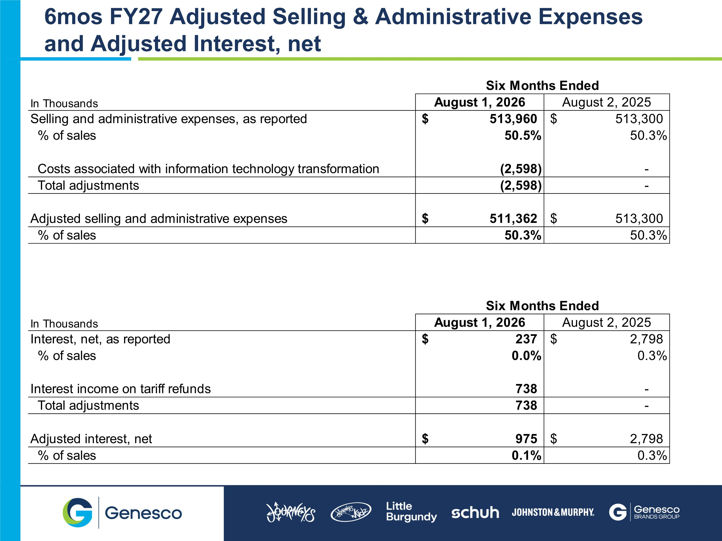
6mos FY27 Adjusted Selling & Administrative Expenses and Adjusted Interest, net


FY27 Q2 GENESCO Summary Results September 3, 2026

